**C:\Users\st11223\Desktop\MIT LOGO ETC\New MIT Logo.png **

**NEW ZEALAND MARITIME SCHOOL**

**NZ Diploma in Marine Electro-technology (NZ2894)**

**(STCW 1978 A-III/6, as amended in 2010)**

**Electro-Technical Officer, Year 2 Cadets, 2020.**

**Course Code**

942.573 – PC01.

**Course Title**

Marine Electro-technology Science, Electronics and Electrical Machines.

Learning Outcomes Assessment.

**Format**

Written assignment of approximately 1200 words including diagrams and marked Competent (C) or Not-Yet Competent (NYC). Weighting = 50%.

**Due Date**

To be submitted by email to [nick.cossar@manukau.ac.nz](mailto:nick.cossar@manukau.ac.nz) for the due date of 23/02/2020.

**Tutor**

Nick Cossar

[nick.cossar@manukau.ac.nz](mailto:nick.cossar@manukau.ac.nz)

**Student Name:** Levi Dubbelman

**Student ID:** 190000929

**Date:** 03/02/2020

Table of Contents

Outcome 1 Demonstrate principles of heat transmission, mechanics and hydrodynamics. 6

Describe and explain the processes of heat transmission. 6

Describe and explain mechanics: scalar and vector quantities, graphical representation of force, resultants, moment of force, equilibrium. 7

Describe and explain hydromechanics: hydrostatics, hydromechanics and fluid flow. 7

Outcome 2 10

Define electrical concepts and laws. 10

Provide definitions for: current, voltage, resistance, capacitance and inductance. 10

Provide definitions for: electrical power and energy. 12

Outcome 3: 12

State DC circuit laws. 12

State Ohm's law and calculates resistance of resistors connected in series and in parallel. 12

State Kirchhoff's laws and use the laws in solving electrical circuits. 14

State Thevenin's theorem and use the theorem in solving electrical circuits. 15

Calculate star-delta transformations. 15

Outcome 4 17

Explain AC circuits and related principles. 17

Describe differences between AC and DC. 17

Define the RMS value of alternating current. 17

Describe representation of sinusoidal quantities by vectors. 18

Sketch phasor diagrams for RL, RC and RLC circuits. 19

Calculate series and parallel RL, RC and RLC circuits using complex numbers. 21

Describe the phenomenon of resonance in series and parallel circuits. 21

Describe the relationship between phase and line voltages in three-phase systems on the basis of phasor diagrams. 22

Explain concepts of active, reactive power, apparent power and power factor in single and three-phase AC circuits. 23

Explain methods of measurement of active, reactive power, apparent power and power factor in three-phase four-wire and three-wire systems. 23

Describe non-sinusoidal voltage and current. 24

State basic methods of calculating RL, RC and RLC circuits in transient states. 25

Calculate transient currents in the simple RL, RC and RLC circuits. 25

Outcome 5 25

Describe magnetic and electromagnetic induction and related principles. 25

Describe the influence of magnetic fields on conductors carrying current. 25

Use Fleming's rule to determine the directions of magnetic field, motion and current. 25

Describe principles of self and mutual induction as well as self and mutually induced EMF. 27

Compare coil inductance with and without an iron core. 27

Outcome 6 27

Explain the principles of electrical machines. 27

Define the term "electrical machine" and detail the classification of electrical machines. 27

An electrical machine is ascribed as any machines using electromagnetic forces, such as electric motors, electric generators, and others. They convert electric forces into mechanical forces, or mechanical forces into electrical forces. Transformers are also included as a type of electrical machine. 27

Describe the typical structure of various machines and the materials used. 27

All electrical machines require a conductor, and therefore, in addition to taking advantage of the tensile strength of steel, copper is used for its effectiveness as a conductor and low cost. However, theoretically any motor or generator could use any conductive material. 27

Explain the efficiency concept of electrical machines and characterize the sources of energy losses. 27

Explain the importance of proper cooling of electrical machines. 27

Name particular features of electrical machines for marine applications and rules for their design, including high voltage machines (above 1 kV). 27

List marine applications for electrical machines. 27

Outcome 7 28

Explain the principles of DC motors. 28

Describe operation principles and properties of DC motors and generators. 28

Draw the arrangement of a DC machine. Identify and explain the function of the armature, the commutator, brushes and springs, field poles and field coils. 28

Differentiate between the features and applications of shunt series and compound DC motors. 28

Describe methods for DC motors start-up and speed control. 28

Outcome 8 28

Explain operating principles of transformers. 28

Describe structures and operating principles of single and three-phase transformers. 28

Sketch equivalent circuits and phasor diagrams for transformers. 28

Draw connection groups for three-phase transformers. 28

Explain consequences for variations of voltage magnitude and frequency on operation of transformers. 28

Describe phenomena which occurs during operation of two transformers in parallel. 28

Outcome 9 28

Explain operating principles of asynchronous machines. 28

Describe structures and operating principles of asynchronous machines. 28

Sketch equivalent circuits and phasor diagrams of asynchronous motors. 29

Draw an arrangement of an asynchronous motor. Identify and explain the rotor (and cage if applicable), field winding, fan, terminals and windings connections. 29

Sketch graphs showing relations between speed and load as well as between current and load, from no load to full load. 29

For a given frequency and motor structure, calculate synchronous speed and explain the term of slip. 29

Describe methods for AC motor start-up and speed control. 29

Describe double squirrel-cage and deep slot motors. 29

Explain the meaning of the information displayed on a motor name plate. 29

Explain consequences of supply voltage and frequency variation on operation of asynchronous motors. 29

Outcome 10 29

Explain operating principles of synchronous machines. 29

Describe structures and operating principles of synchronous machines. 29

Describe properties of synchronous generators. 29

Explain armature reaction. 29

Sketch equivalent circuits and phasor diagrams for synchronous generators. 29

Explain the operation of the synchronous machine as motor and pf compensator. 29

Compare properties of cylindrical and salient pole machines. 29

Outcome 11 30

Explain operating principles of special machines. 30

Describe construction and operating principles of AC commutator motors, AC single phase motors, and reluctance and permanent magnet machines. 30

Outcome 12 30

Demonstrate operating principles of electronics and power electronics. 30

Describe the structure, principle of operation, parameters and application of different semiconductor elements: diodes, SCR, GTO and IGCT thyristors, field effect transistors — MOSFET and JFET, IGBT transistors. 30

List classification of power electronic converters and areas of their application on ships. 30

List parameters, properties and basic applications of integrated stabilizers and operational amplifiers. 30

Describe structure and operation of analogue and impulse DC power supplies. 30

Describe the construction and operation of controlled rectifiers. 30

Describe the construction and operation of AC voltage controllers. 30

Describe principle of operation and properties of MSI inverters. 30

Describe the principle of operation and properties of cyclo-converters. 30

List diagnostics, methods of assembly and replacement of semiconductor elements. 30

List the requirements for electronic and power electronic systems installed on ships. 30

# Outcome 1

## Demonstrate principles of heat transmission, mechanics and hydrodynamics.

### Describe and explain the processes of heat transmission.

Heat, i.e. thermal energy may be transferred in three separate ways.

1. Convection

When a fluid or gas is heated and then travels away from the source, it acts a container for thermal energy and carries it along with it as well. This type of heat transmission is known as convection.

Natural convection typically occurs because the density of a transmission medium is being altered by a corresponding increase or decrease in temperature. A common example of this is air being warmed and then rising away from the thermal source.

Forced convection, or heat advection, occurs when an external force is responsible for the movement of the transmission medium. Typically, this is due to a forced draft fan, or pump. Forced convection is often employed to increase the rate of heat exchange, for example to change the temperature of a room for comfort, or to ensure equipment is operating within safe temperature thresholds.

1. Conduction

When a physical connection is made between two materials with a thermal differential, a transfer of heat energy occurs. Atomically speaking, heat is simply the agitation of atoms, and this agitation may spread by collision. When contact occurs with a hotter or colder surface, atoms within the contacting surface will immediately begin vibrating more (in the case of a hotter surface) or less (in the case of a colder surface). Common examples of conduction include heat exchangers, which conduct large amounts of heat, which may otherwise be wasted, for use in other useful purposes which demand heating.

1. Radiation

When an election absorbs energy, it will temporarily “jump” to a higher orbit around an atom. When that electron “falls” down to its original tier, it will release a photon. When a photon is released, it passes through a vacuum or transparent material until it collides with something. This is process by which radiation of heat occurs. A common example of radiated heat is the Sun, by which massive quantities of heat is radiated over a vacuum.

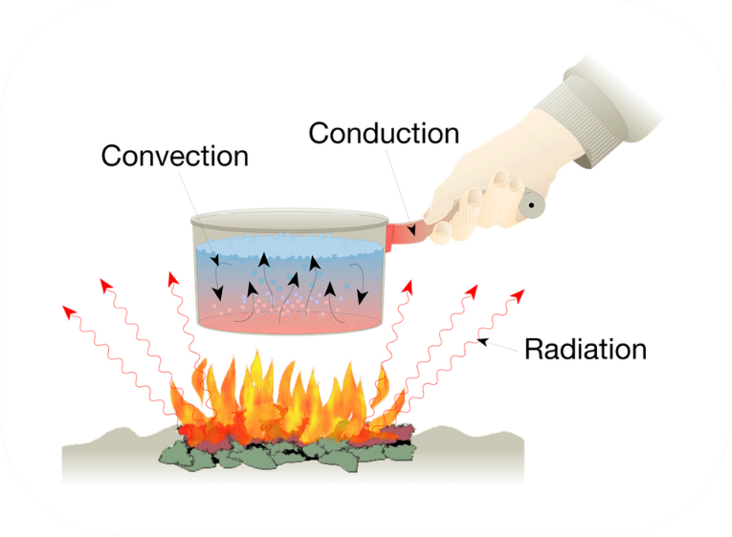

Convection, conduction and radiation

### Describe and explain mechanics: scalar and vector quantities, graphical representation of force, resultants, moment of force, equilibrium.

A scalar quantity has only *magnitude.* Which is an attribute, or property, and is not a function of direction. Examples include length, speed, density and mass.

A vector quantity includes both *magnitude* and *direction*. Examples include velocity, momentum, force and mass.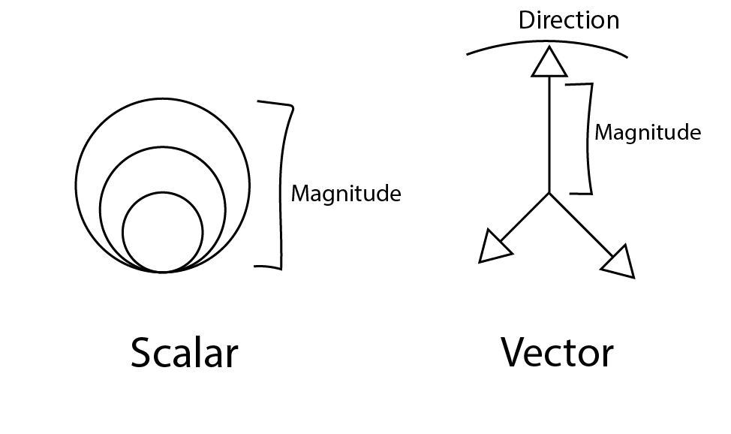

### Describe and explain hydromechanics: hydrostatics, hydromechanics and fluid flow.

Hydrostatics is the study of fluids at rest.

Hydrostatics includes fields of study such as fluids at rest in a tank (i.e. ballasting and stability on ships), as well as the buoyant force applied to ships, and is extremely important due to the massive quantity of static fluids held within tanks aboard vessels.

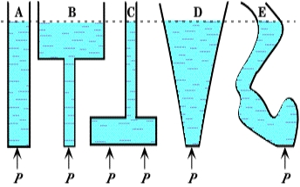

Hydrostatic pressure

Hydromechanics is an umbrella term to describe the subdisciplines of hydrostatics and fluid dynamics. It deals with the interaction of any fluid, including gases, with the environment around it. Both hydrostatics and fluid flow fit into this discipline.

Fluid flow is the study of mechanics of fluids or the laws of equilibrium and motion concerning fluids. This includes how water flowing over a prop produces thrust or how water passes over ship’s hull and how it interacts with piping at high pressures and is important for efficiency, maintenance and safety reasons.

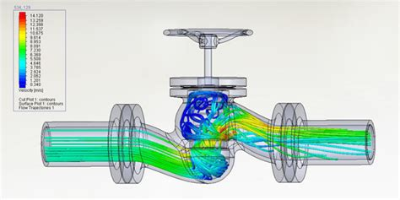

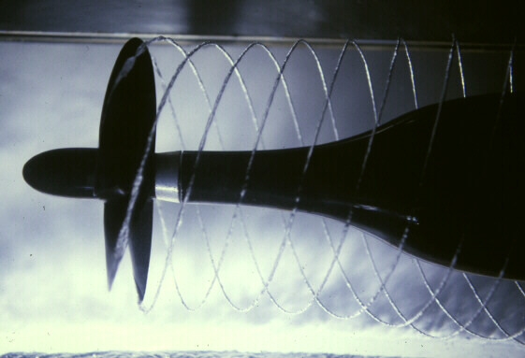

# Outcome 2

## Define electrical concepts and laws.

### Provide definitions for: current, voltage, resistance, capacitance and inductance.

**Current**

Current is the flow of electrons in a conductor over a period. One ampere is described as one coulomb of charge per second.

**Voltage**

Voltage, or electromotive force, is the measure of potential current flow between two points. One volt is described as the *work* needed per unit of charge to move a test charge between two points.

**Resistance**

Electrical resistance is the opposition offered by an electrical conductor to the flow of current. Generally, this resistance results in a type of frictional heat and potentially radiation being generated. One ohm is described as amount of resistance present in a conductor which allows one ampere of current to flow when subjected to one volt.

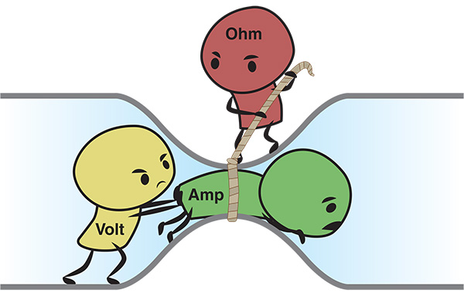

**Capacitance**

Capacitance is defined as the difference, or ratio of change in electric charge, against

a corresponding change in electric potential. Capacitance is divided into two categories:

self-capacitance and mutual capacitance. Capacitance is measured in Farads (F).

However, in most electrical circuits, a Farad is significantly larger than the capacitors used.

Therefore, it is not uncommon to see Microfarad (µF), Nano-farad (nF), or Picofarad

(pF) capacitors. It should also be noted that capacitance is an effect exclusively present

on alternating current circuits. In capacitors, a phenome occurs whereby the current in

the circuit lags the voltage, which generates reactive power.

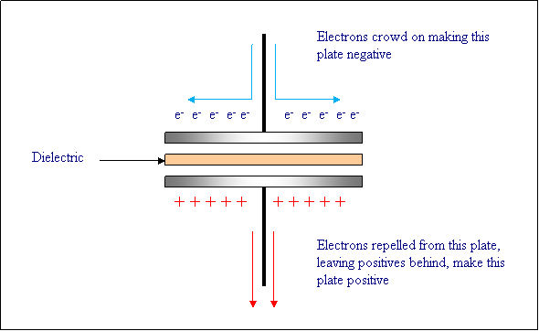

**Self-Capacitance**

When discussing capacitance, it is usually referencing mutual capacitance. However,

for an isolated conductor there is a property of self-capacitance. Self-capacitance is the

amount of electric charge that must be added to an isolated conductor to raise

its electric potential by one volt.

**Mutual Capacitance**

The most commonly mentioned form of capacitance is mutual capacitance. Mutual capacitance is where two conductors are separated by an insulating, or dielectric material.

**Inductance**

Inductance, or more accurately self-inductance, is the property of an electromotive

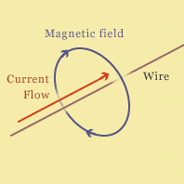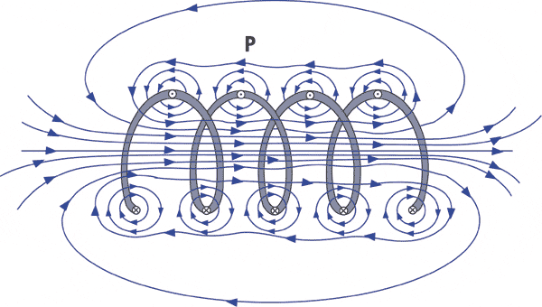force being applied in opposition to the current in an inductive conductor. Any charge flowing through the circuit loses potential energy when transitioning from the higher voltage to the lower voltage section. Energy required to overcome the ’potential threshold’ is stored in a magnetic field around the inductive conductor. A current (i) flowing through a conductor generates a magnetic field around the conductor, which is described by Ampere’s circuital law. The total magnetic flux through a circuit (Φ) is equal to the product of the magnetic field and the area of the surface spanning the current path. If the current varies, the magnetic flux Φ through the circuit changes. By Faraday’s law of induction, any change in flux through a circuit induces an electromotive force (EMF) or voltage (V) in the circuit, proportional to the rate of change of flux. The unit for inductance is a henry Symbol: H. An electrical circuit is ascribed the inductance of one henry when an electric current that is changing at one ampere per second results in an electromotive force of one volt across the inductor.

### Provide definitions for: electrical power and energy.

**Power**

Power is defined as the *rate* of doing *work.* It is best represented as the equation:

Where P is power, Delta W is the change in work (usually positive i.e. work done to the system) and Delta t is the change in time.

The SI unit for electrical power is the *Watt* which is defined as one *joule* per second.

**Energy**

Energy is the capacity to do work; the influence required to act. The amount of energy in a system is the amount of change that can be made to it. Energy is a property that is not created or destroyed, although energy can change in detectable form.

# Outcome 3:

## State DC circuit laws.

### State Ohm's law and calculates resistance of resistors connected in series and parallel.

Ohm's law states that the current through a conductor between two points is directly proportional to the voltage across the two points.

Where *E* is the electromotive force, measured in volts, *R* is the resistance to current flow, and *I* is the flow of elections.

**Resistors in Parallel**

For example

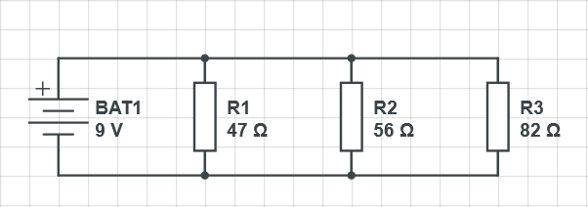

**Resistors in Series**

For example

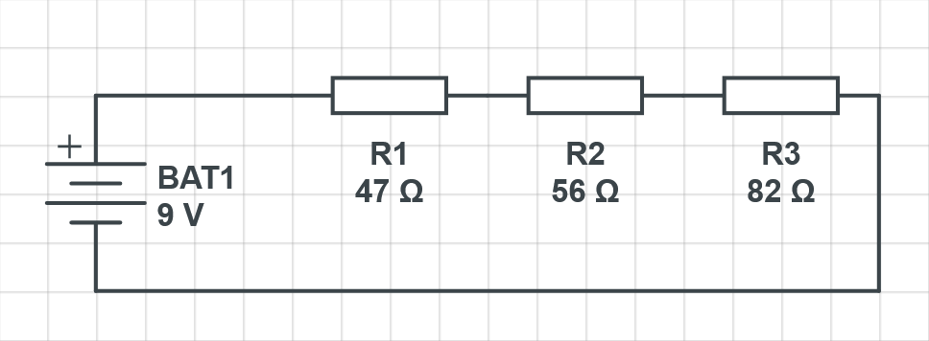

### State Kirchhoff's laws and use the laws in solving electrical circuits.

**Kirchoff’s Current Law**

The algebraic sum of currents in a network of conductors meeting at a point is zero. 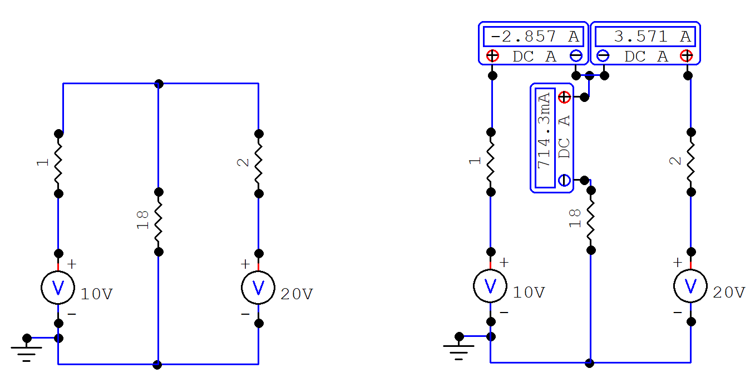

A

**Kirchoff’s Voltage Law**

The directed sum of the potential differences (voltages) around any closed loop is zero. 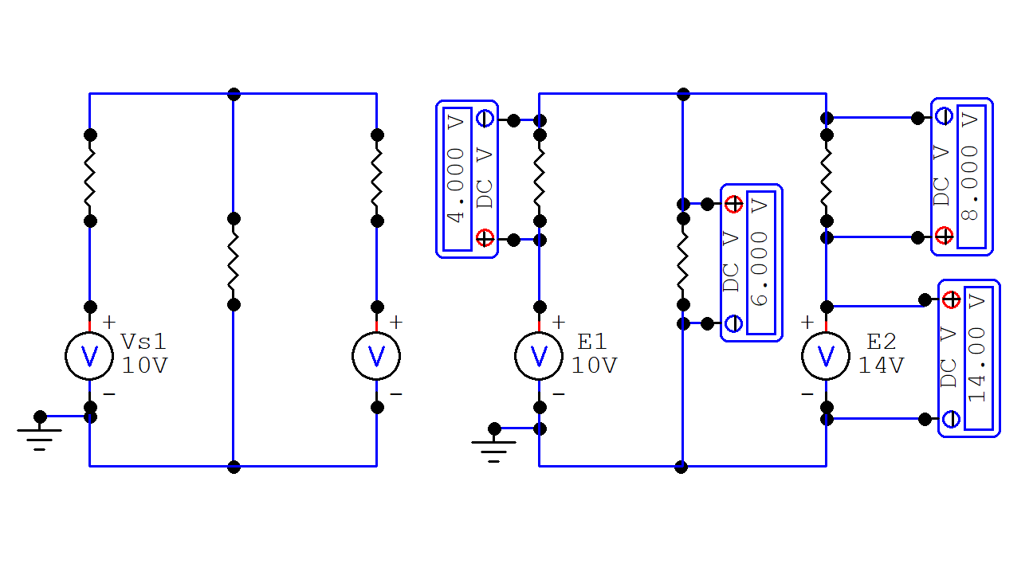

### State Thevenin's theorem and use the theorem in solving electrical circuits.

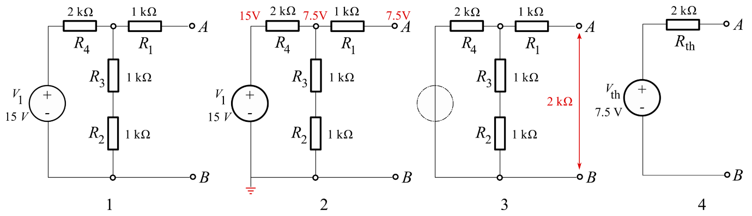Thevenin’s Theorem states that – any complicated network across its load terminals can be substituted by a voltage source with one resistance in series.

### Calculate star-delta transformations.

If a 3-phase, 3-wire supply or even a 3-phase load is connected in one type of configuration, it can be easily transformed or changed it into an equivalent configuration of the other type by using either the Star Delta Transformation or Delta Star Transformation process.

**T and equivalent Star**

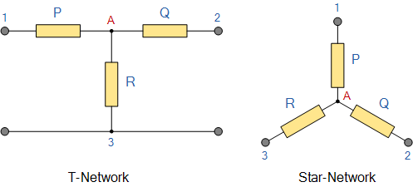

**Pi and equivalent Delta**

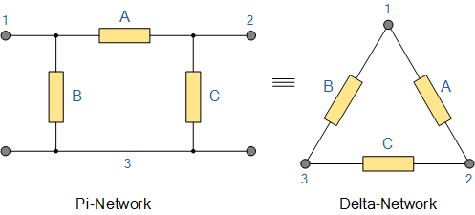

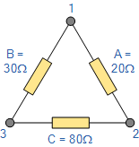

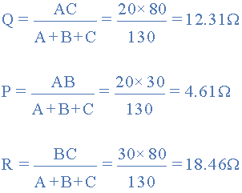

Source: <https://www.electronics-tutorials.ws/dccircuits/dcp_10.html>

# Outcome 4

## Explain AC circuits and related principles.

### Describe differences between AC and DC.

The primary difference between alternating current and direct current is the method of transmission of electrical charge. Direct Current has a positive and negative point. By convention, the direction of current flow is from the positive terminal to the negative terminal, although the actual electron flow is the opposite. Alternating Current, on the other hand, has one or more phases. In shore-based applications, generally this is a single phase, with the other terminal providing a neutral, or ground, providing an electric potential, allowing current flow. These live phases have a rotating waveform known as a sinusoid. A period of positive electron flow is then followed by a period of negative electron flow. The length of the total period is measured in Hertz (Hz). While this frequency may be theoretically any number from >0 Hz upwards, trending towards infinity. It should be noted, however for calculation purposes that direct current has a frequency of 0, and this lack of frequency is why there is no capacitance or inductance component in direct current circuits.

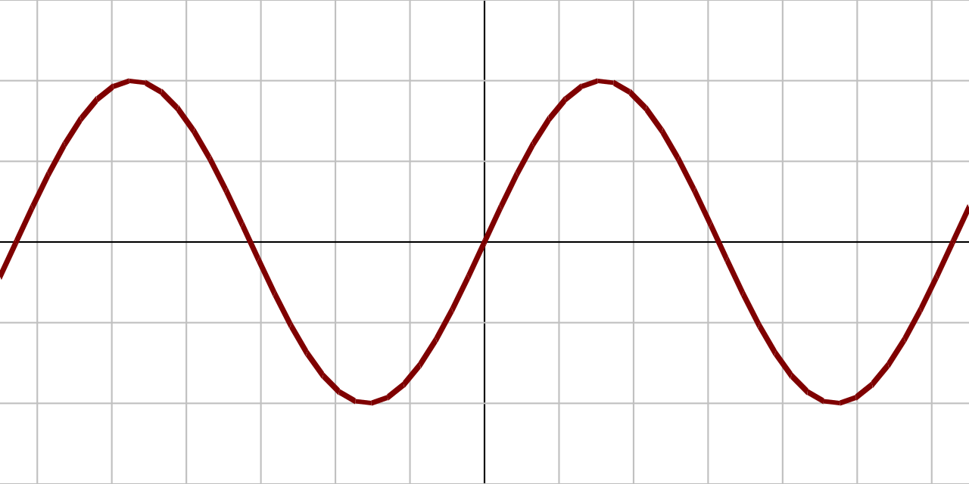

AC Sinusoidal waveform

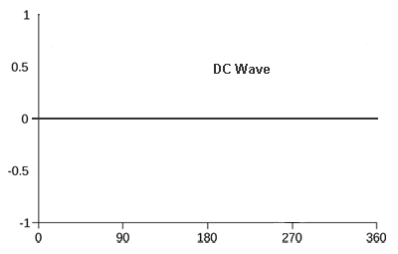

### Define the RMS value of alternating current.

R.M.S., root-mean squared, or quadratic mean is shorthand for the square of the function that define the continuous waveform, typically of an AC supply. For a sine wave, the R.M.S. is exactly 0.707 of the peak-to-peak voltage (i.e. divided by the square root of two). The R.M.S. value is important as it represents the direct-current equivalent, i.e. visible output in electronics

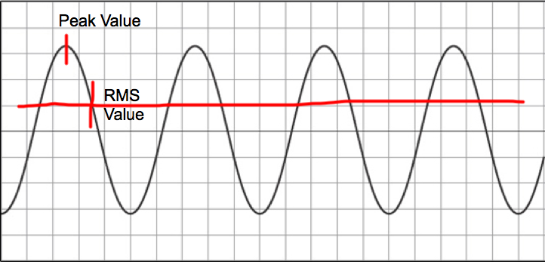

### Describe representation of sinusoidal quantities by vectors.

Sinusoidal quantities such as current and voltage may be represented as vectors. These are known as phasors and have both magnitude and direction.

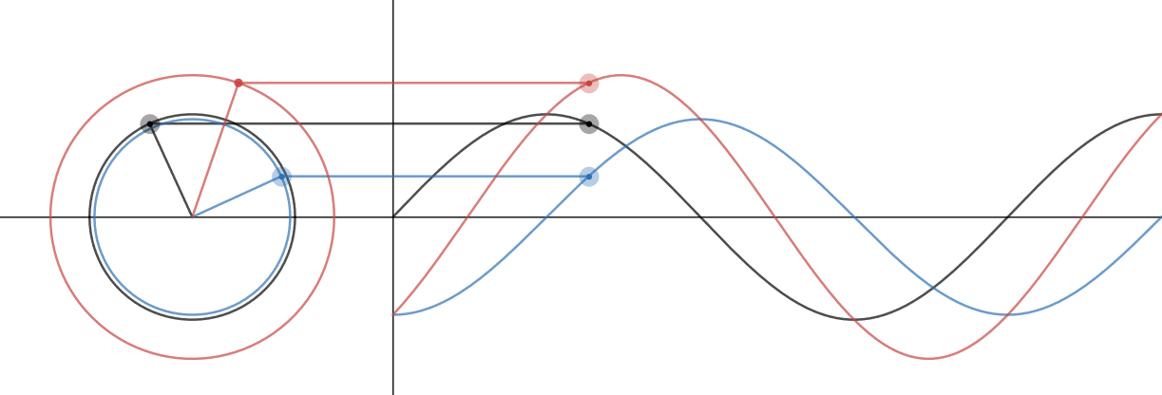

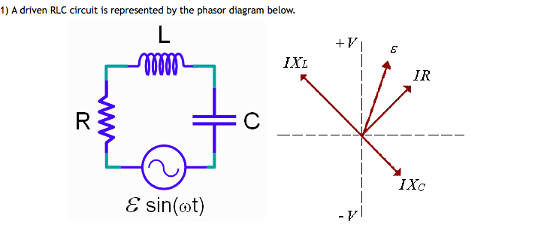

### Sketch phasor diagrams for RL, RC and RLC circuits.

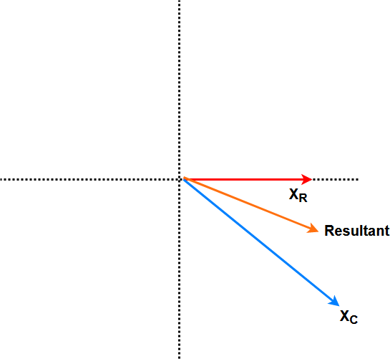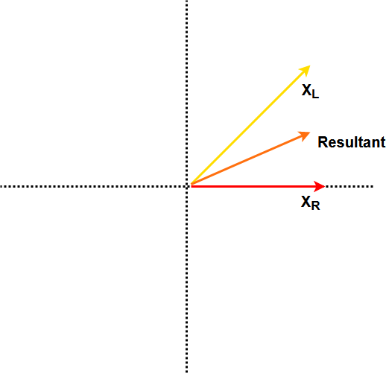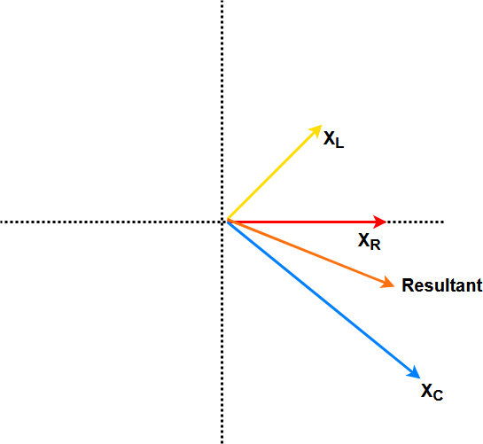

### Calculate series and parallel RL, RC and RLC circuits using complex numbers.

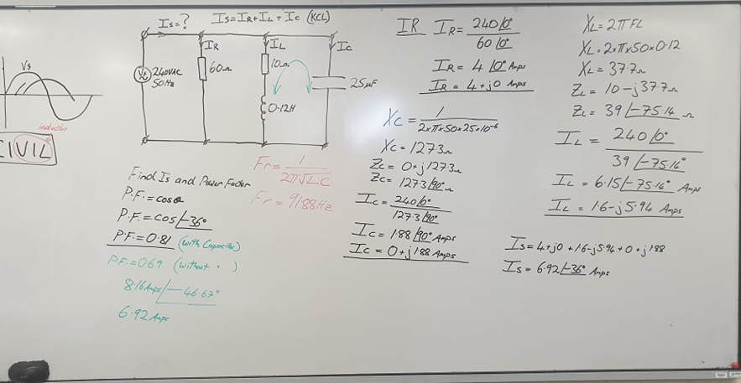

### Describe the phenomenon of resonance in series and parallel circuits.

In simple reactive circuits with little or no resistance, the effects of radically altered impedance will manifest at the resonance frequency predicted by the equation given earlier. In a parallel (tank) LC circuit, this means infinite impedance at resonance. In a series LC circuit, it means zero impedance at resonance:

However, as soon as significant levels of resistance are introduced into most LC circuits, this simple calculation for resonance becomes invalid.

Source: [https://www.allaboutcircuits.com/textbook/alternating-current/chpt-6/resonance-series-parallel-circuits/](%20https:/www.allaboutcircuits.com/textbook/alternating-current/chpt-6/resonance-series-parallel-circuits/)

To recap, the capacitor has a capacitive reactance XC given by . The inductor has an inductive reactance XL given by . We saw that the magnitude of the total impedance can be given by

The current I through the circuit is given by . If we change the frequency f of the AC, we can change both and . As these values change, the total impedance of the circuit will also change. This would mean that the size of the current through the circuit would change as well. In particular, when we look at the equation for impedance, we can see that when , the impedance is minimum ). At this value, therefore, the current through the circuit would be at a maximum. The graph below depicts how the current through the circuit changes, as we change the frequency of the AC.

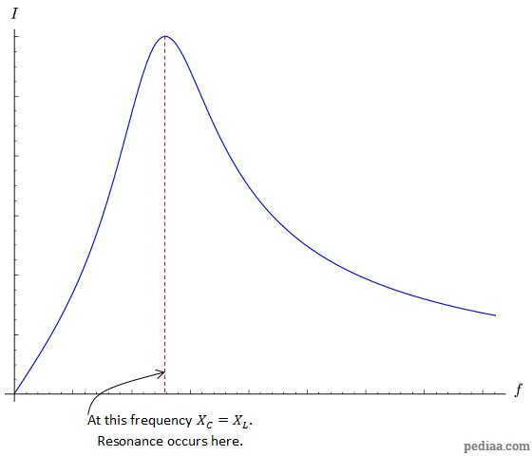

A graph of current vs. frequency for a series RLC resonant circuit

At the resonant frequency, . This means that . We can solve this to show that the resonance frequency is given by:

Source: <https://pediaa.com/difference-between-series-and-parallel-resonance/>

### Describe the relationship between phase and line voltages in three-phase systems based on phasor diagrams.

The angle between phases is 120 degrees. The angle between line and earth is ±90 degrees. This means the potential between two phases is always an order of the square root of N number of phases greater than line voltage. For example, Line voltage may be 220V RMS, or 410V phase-to-phase.

### Explain concepts of active, reactive power, apparent power and power factor in single and three-phase AC circuits.

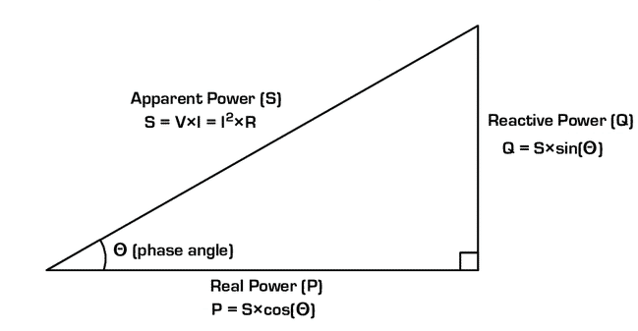

1. Apparent Power is the hypotenuse of Reactive and Real Power.
2. Reactive Power is non-useful power lost to overly inductive or capacitive loads.
3. Real power is the useful power which is utilized by the load.
4. The phase angle cosine theta is the “power factor” between 0 and 1 which represents at a glance the ratio of Real to Reactive power. Approaching but not exactly 1 power factor is ideal for minimizing losses.

### Explain methods of measurement of active, reactive power, apparent power and power factor in three-phase four-wire and three-wire systems.

### Describe non-sinusoidal voltage and current.

Voltage and current may be intentionally non-sinusoidal, such as pulse-width modulation.

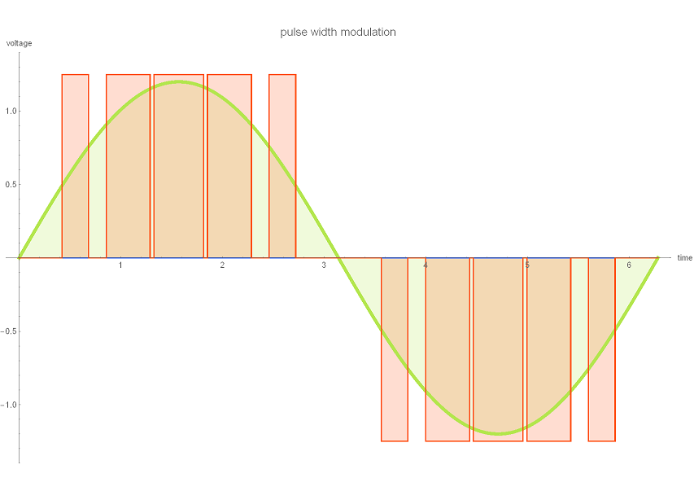

Pulse width modulation (PWM) is a powerful technique for controlling analog circuits with a processor's digital outputs. PWM is employed in a wide variety of applications, ranging from measurement and communications to power control and conversion.

Or they may be unintentional and cause negative effects, such as harmonics.

A pure sinusoidal voltage is a conceptual quantity produced by an ideal AC generator built with finely distributed stator and field windings that operate in a uniform magnetic field. Since neither the winding distribution nor the magnetic field are uniform in a working AC machine, voltage waveform distortions are created, and the voltage-time relationship deviates from the pure sine function. The distortion at the point of generation is very small (about 1% to 2%), but it exists. Because this is a deviation from a pure sine wave, the deviation is in the form of a periodic function, and by definition, the voltage distortion contains harmonics.

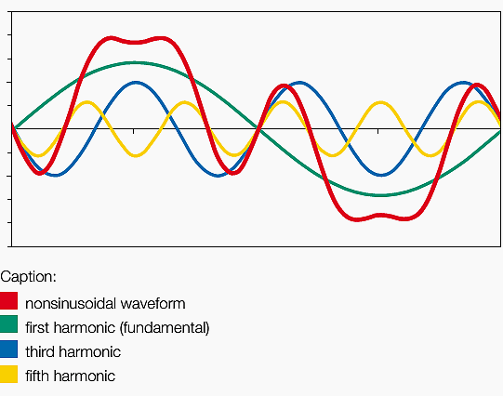

### Describe usage of concept of Fourier series for non-sinusoidal voltage and current representation.

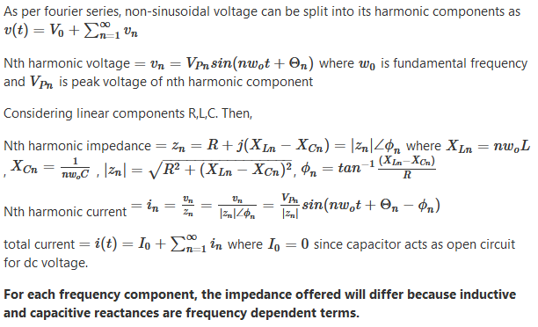

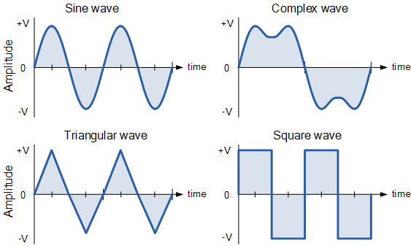

Source: [Quora](https://www.quora.com/When-a-non-sinusoidal-voltage-is-applied-to-an-electrical-circuit-with-linear-elements-the-current-wave-will-also-be-non-sinusoidal-but-the-network-impedance-will-be-different-from-each-of-the-components-voltages?share=1)

### State basic methods of calculating RL, RC and RLC circuits in transient states.

When there is a step change (or switching) in a circuit with capacitors and inductors together, a transient also occurs. With some differences:

* Energy stored in capacitors (electric fields) and inductors (magnetic fields) can trade back and forth during the transient, leading to possible “ringing” effects.
* The transient waveform can be quite different, depending on the exact relationship of the values of C, L, and R.
* The mathematic relationship is more involved.

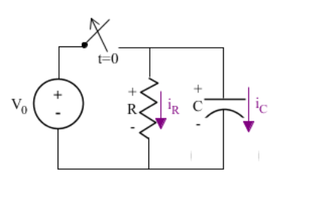

Voltage is applied from the voltage source and the circuit is at a steady state. The response or output of the circuit is the voltage across the capacitor. We know that before the switch is opened, the response of the circuit will be a constant V0. The current will be zero because the voltage is not changing (current through a capacitor is dependent on the derivative of the voltage).

A long time after the switch is opened and the capacitor has discharged, the system will again reach a steady state. The voltage remains constant at zero, and the current is also zero because of the constant voltage across the capacitor. However, immediately after the switch is opened, the circuit enters the transient state because it has been disturbed. It takes time to return to a steady state. The complete response is both the transient response and the steady state response.

Sinusoidal steady states require that the response has the same frequency of the input and is also sinusoidal.

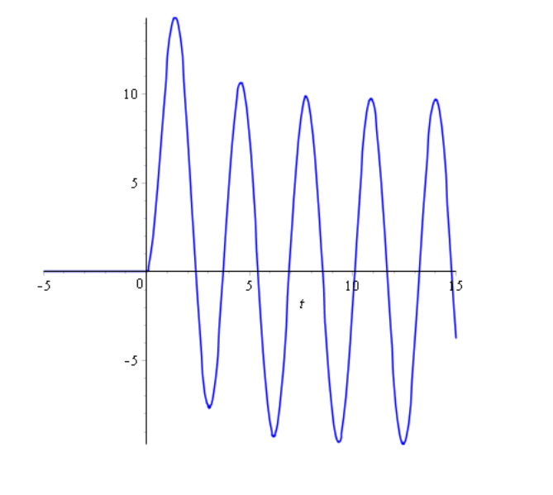

### Calculate transient currents in the simple RL, RC and RLC circuits.

The first step is to identify the starting and final values for whatever quantity the capacitor or inductor opposes the change in; that is, whatever quantity the reactive component is trying to hold constant. For capacitors, this quantity is *voltage*; for inductors, this quantity is *current*. When the switch in a circuit is closed (or opened), the reactive component will attempt to maintain that quantity at the same level as it was before the switch transition, so that value is to be used for the “starting” value. The final value for this quantity is whatever that quantity will be after an infinite amount of time. This can be determined by analysing a capacitive circuit as though the capacitor was an open-circuit, and an inductive circuit as though the inductor was a short-circuit because that is what these components behave as when they’ve reached “full charge,” after an infinite amount of time.

The next step is to calculate the *time constant* of the circuit: the amount of time it takes for voltage or current values to change approximately 63 percent from their starting values to their final values in a transient situation. In a series RC circuit, the time constant is equal to the total resistance in ohms multiplied by the total capacitance in farads. For a series L/R circuit, it is the total inductance in henrys divided by the total resistance in ohms. In either case, the time constant is expressed in units of *seconds* and symbolized by the Greek letter “tau” (τ):

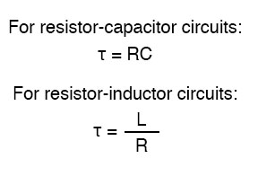

The rise and fall of circuit values such as voltage and current in response to a transient are, as was mentioned before, *asymptotic*. Being so, the values begin to rapidly change soon after the transient and settle down over time. If plotted on a graph, the approach to the final values of voltage and current form exponential curves.

As was stated before, one time constant is the amount of time it takes for any of these values to change about 63 percent from their starting values to their (ultimate) final values. For every time constant, these values move (approximately) 63 percent closer to their eventual goal. The mathematical formula for determining the precise percentage is quite simple:

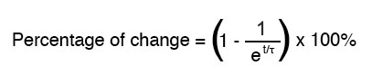

The letter *e* stands for Euler’s constant, which is approximately 2.7182818. It is derived from calculus techniques, after mathematically analysing the asymptotic approach of the circuit values. After a single time constant’s worth of time, the percentage of change from starting value to final value is:

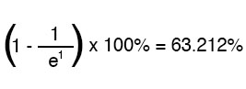

After two time constants’ worth of time, the percentage of change from starting value to final value is:

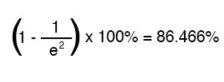

After ten times the constant’s worth of time, the percentage is:

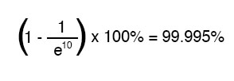

The more time that passes since the transient application of voltage from the battery, the larger the value of the denominator in the fraction, which makes for a smaller value for the whole fraction, which makes for a total (1 minus the fraction) approaching 1, or 100 percent.

We can make a more universal formula out of this one for the determination of voltage and current values in transient circuits, by multiplying this quantity by the difference between the final and starting circuit values:

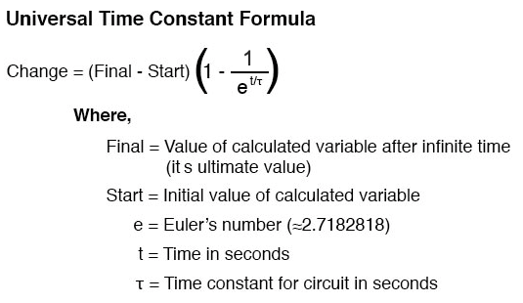

Let’s analyze the voltage rise on the series resistor-capacitor circuit shown at the beginning of the chapter.

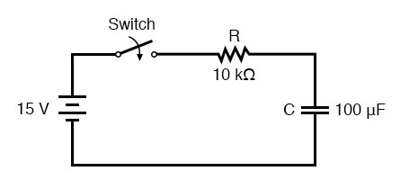

Note that we’re choosing to analyze voltage because that is the quantity capacitors tend to hold constant. Although the formula works quite well for current, the starting and final values for current are derived from the capacitor’s voltage, so the calculating voltage is a more direct method. The resistance is 10 kΩ, and the capacitance is 100 µF (microfarads). Since the time constant (τ) for an RC circuit is the product of resistance and capacitance, we obtain a value of 1 second:

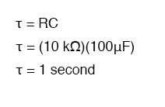

If the capacitor starts in a discharged state (0 volts), then we can use that value of voltage for a “starting” value. The final value, of course, will be the battery voltage (15 volts). Our universal formula for capacitor voltage in this circuit looks like this:

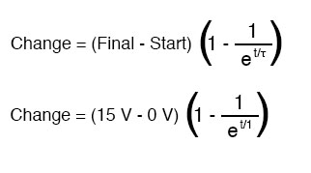

So, after 7.25 seconds of applying a voltage through the closed switch, our capacitor voltage will have increased by:

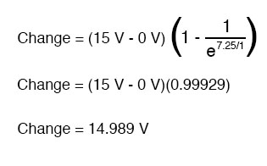

Since we started at a capacitor voltage of 0 volts, this increase of 14.989 volts means that we have 14.989 volts after 7.25 seconds.

The same formula will work for determining the current in that circuit, too. Since we know that a discharged capacitor initially acts like a short-circuit, the starting current will be the maximum amount possible: 15 volts (from the battery) divided by 10 kΩ (the only opposition to current in the circuit at the beginning):

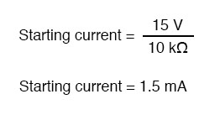

We also know that the final current will be zero, since the capacitor will eventually behave as an open-circuit, meaning that eventually, no electrons will flow in the circuit. Now that we know both the starting and final current values, we can use our universal formula to determine the current after 7.25 seconds of switch closure in the same RC circuit:

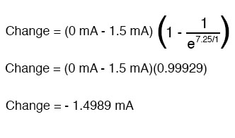

Note that the figure obtained for change is negative, not positive! This tells us that the current has *decreased* rather than increased over time. Since we started at a current of 1.5 mA, this decrease (-1.4989 mA) means that we have 0.001065 mA (1.065 µA) after 7.25 seconds.

We could have also determined the circuit current at time=7.25 seconds by subtracting the capacitor’s voltage (14.989 volts) from the battery’s voltage (15 volts) to obtain the voltage drop across the 10 kΩ resistor, then figuring current through the resistor (and the whole series circuit) with Ohm’s Law (I=E/R). Either way, we should obtain the same answer:

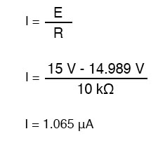

Source: <https://www.allaboutcircuits.com/textbook/direct-current/chpt-16/voltage-current-calculations/>

# Outcome 5

## Describe magnetic and electromagnetic induction and related principles.

### Describe the influence of magnetic fields on conductors carrying current.

The Hall effect is the phenomenon in which a voltage difference (called the Hall voltage) is produced across an electrical conductor, transverse to the conductor’s electric current when a magnetic field perpendicular to the conductor’s current is applied.

When a magnetic field is present that is not parallel to the motion of moving charges within a conductor, the charges experience the Lorentz force. In the absence of such a field, the charges follow a roughly straight path, occasionally colliding with impurities.

In the presence of a magnetic field with a perpendicular component, the paths charges take becomes curved such that they accumulate on one face of the material. On the other face, there is an excess of opposite charge remaining. Thus, an electric potential is created so long as the charge flows. This opposes the magnetic force, eventually to the point of cancelation, resulting in electron flow in a straight path.

For a metal-containing only one type of charge carrier (electrons), the Hall voltage (VH) can be calculated as a factor of current (I), magnetic field (B), the thickness of the conductor plate (t), and charge carrier density (n) of the carrier electrons:

In this formula, e represents the elementary charge.

The Hall coefficient (RH) is a characteristic of a conductor’s material, and is defined as the ratio of the induced electric field (Ey) to the product of current density (jx) and applied magnetic field (B):

The Hall effect is a rather ubiquitous phenomenon in physics and appears not only in conductors, but semiconductors, ionized gases, and quantum spin among other applications.

When an electrical wire is exposed to a magnet, the current in that wire will be affected by a magnetic field. The effect comes in the form of a force. The expression for magnetic force on current can be found by summing the magnetic force on each of the many individual charges that comprise the current. Since they all run in the same direction, the forces can be added.

The force (F) a magnetic field (B) exerts on an individual charge (q) traveling at drift velocity vd is:

In this instance, θ represents the angle between the magnetic field and the wire (magnetic force is typically calculated as a cross-product). If B is constant throughout a wire and is 0 elsewhere, then for a wire with N charge carriers in its total length l, the total magnetic force on the wire is:

.

Given that N=nV, where n is the number of charge carriers per unit volume and V is the volume of the wire, and that this volume is calculated as the product of the circular cross-sectional area A and length (V=Al), yields the equation:

.

The terms in parentheses are equal to current (I), and thus the equation can be rewritten as:

The direction of the magnetic force can be determined using the right-hand rule. The thumb is pointing in the direction of the current, with the four other fingers parallel to the magnetic field. Curling the fingers reveals the direction of the magnetic force.

### Use Fleming's rule to determine the directions of the magnetic field, motion, and current.

**Fleming’s Rule**

Fleming’s Rule to determine directions of the magnetic field, motion and Current When there is a current-carrying conductor is acted upon by a magnetic flux, as per Faraday’s Law, a force will also act upon the conductor. The direction of this force can be found using Fleming’s "Left Hand Rule", which is sometimes referred to as Fleming’s Left-Hand Rule for Motors". This force is found to be perpendicular to both the directions of the current and magnetic fields. While current flows through a conductor, one magnetic field is induced around it. The magnetic field can be imagined by considering the numbers of closed magnetic lines of force around the conductor. The direction of magnetic lines of force can be determined by Maxwell’s corkscrew rule or right-hand grip rule. As per these rules, the direction of the magnetic lines of force (or flux lines) is clockwise if the current is flowing away from the viewer, that is if the direction of current through the conductor is inward from the reference plane as shown in the figure.

Fleming’s Right Hand Rule proves to be equal and opposite, sometimes known as "Fleming’s Right-Hand Rule for Generators". Whenever a conductor moves inside a magnetic field, there will be an induced current in it. If this conductor gets forcefully moved inside the magnetic field, there will be a relation between the direction of applied force, magnetic field, and the current.

### State Faraday's law.

**Faraday’s Law**

The electromotive force around a closed path is equal to the negative of the time rate of change of the magnetic flux enclosed by the path. Faraday’s Law of Electromagnetic Induction describes how an electric current produces a magnetic field and, conversely, how a changing magnetic field generates an electric current in a conductor. Faraday visualized a magnetic field as composed of many lines of induction, along which a small magnetic compass would point. The aggregate of the lines intersecting a given area is called the magnetic flux. The electrical effects were thus attributed by Faraday to a changing magnetic flux. Some years later the Scottish physicist James Clerk Maxwell proposed that the fundamental effect of changing magnetic flux was the production of an electric field, not only in a conductor (where it could drive an electric charge) but also in space even in the absence of electric charges. Maxwell formulated the mathematical expression relating the change in magnetic flux to the induced electromotive force (E, or emf). This relationship, known as Faraday’s law of induction (to distinguish it from his laws of electrolysis), states that the magnitude of the emf induced in a circuit is proportional to the rate of change of the magnetic flux that cuts across the circuit. If the rate of change of magnetic flux is expressed in units of webers per second, the induced emf has units of volts.

### State Lenz's law.

**Lenz’s Law**

Nature abhors a change in flux.

Lenz’s law states that when an emf is generated by a change in magnetic flux according to Faraday’s Law, the polarity of the induced emf is such, that it produces a current whose magnetic field opposes the change which produces it. Thrusting a pole of a permanent bar magnet through a coil of wire, for example, induces an electric current in the coil; the current, in turn, sets up a magnetic field around the coil, making it a magnet. Lenz’s law indicates the direction of the induced current. Because like magnetic poles repel each other, Lenz’s law states that when the north pole of the bar magnet is approaching the coil, the induced current flows in such a way as to make the side of the coil nearest the pole of the bar magnet itself a north pole to oppose the approaching bar magnet. Upon withdrawing the bar magnet from the coil, the induced current reverses itself, and the near side of the coil becomes a south pole to produce an attractive force on the receding bar magnet.

### Compare coil inductance with and without an iron core.

An iron core transformer has a big block of iron that the wire coils wrap around.  (Actually, it may not be a block, but rather a set of "E" shaped sheets stacked alternately on top of each other to minimize eddy currents, but an older one might be a block).  You want the iron block there because it increases the inductance and mutual inductance of the transformer to behave closer to the ideal V1/V2 = N1/N2 formula.  (Ideal requires *infinite* inductance, but it gets close with high inductance).  
  
However, iron exhibits a phenomenon known as Hysteresis, where when it gets magnetized past a certain limit it saturates and the transformer windings no longer act as an ideal transformer.

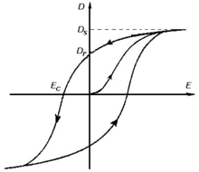

An air-core transformer does not have an iron core, instead, it's just coiled around perhaps a piece of plastic, with air in the center.  It doesn't behave quite like an ideal transformer because of its low inductance (it behaves quite literally like a pair of mutually coupled inductors because that's what it is).  However, the fact that the air doesn't exhibit hysteresis makes it so that it can be used without distortion over an effectively infinite range.

Source: [Quora](https://www.quora.com/What-is-the-difference-between-iron-core-and-air-core?share=1)

# Outcome 6

## Explain the principles of electrical machines.

### Define the term "electrical machine" and detail the classification of electrical machines.

An electrical machine is any kind of device which converts to electrical or mechanical energy from mechanical or electrical energy. An electrical machine is broadly classified into two types:

I) Static Machines and II) Rotating Machines

In static machines Refers to stationary machines i.e., a transformer that may be single or three-phase transformers.

In dynamic machines refers to both DC and AC Machines.

DC Machines refers to both DC Motor and Generators.

AC Machines refers to synchronous and asynchronous machines.

Synchronous machines refer to both synchronous motors and synchronous generators

Asynchronous machines refer to induction motors which may be single or three phases (based on rotor construction they are squirrel cage and slip ring induction motor).

### Describe the typical structure of various machines and the materials used.

Steel laminate is often used in rotor windings or transformer ferrous cores to reduce the effect of eddy currents. Copper is used heavily as the primary conductor within the construction of electrical machines. Steel or cast-iron stators are common as well, typically with heat sinking.

Plastic Insulation Types

Polyvinyl Chloride (PVC)

A PVC jacket is a relatively inexpensive and easy-to-use material with the potential to be used in diverse applications. The maximum temperature range is minus 55 degrees Celsius to 105 degrees Celsius and is resistant to flame, moisture, and abrasion. It also holds up against gasoline, ozone, acids, and solvents.1 It can also be used for medical- and food-related purposes as it is odorless, tasteless and nontoxic. PVC jackets can be used in heavy- and thin-wall applications. PVC should not be used when flexibility and extended flex life are required at low temperatures. When used in retractile cord applications, it also shows below-average flexibility. PVC jackets display high attenuation and capacitance loss, meaning that power is lost when used in an electrical system.

Semi-Rigid PVC (SR-PVC)

This is mainly used as primary insulation and is very abrasion-resistant. (For 30-16 gauge, a 10-mil. wall meets UL style 1061, 80 degrees Celsius, 300 volts.) Semi-rigid PVC is also resistant to heat, water, acid, and alkali as well as flame-retardant.

Plenum Polyvinyl Chloride (Plenum PVC)

Plenum PVC is suitable for use in building spaces behind dropped ceilings or raised floors left open to allow for air circulation. Standard PVC is considered a non-plenum insulation option because it does not exhibit the qualities necessary for safe usage in plenum areas. To be plenum-rated, the insulation must meet more-stringent fire safety regulations.

Polyethylene (PE)

This compound is used most in coaxial and low-capacitance cables because of its exemplary electric qualities. Many times, it is used in these applications because it is affordable and can be foamed to reduce the dielectric constant to 1.50, making it an attractive option for cables requiring high-speed transmission. Polyethylene can also be cross-linked to produce high resistance to cracking, cut-through, soldering, and solvents. Polyethylene can be used in temperatures ranging from negative 65 degrees Celsius to 80 degrees Celsius. All densities of polyethylene are stiff, hard and inflexible. The material is also flammable. Additives can be used to make it flame-retardant, but this will sacrifice the dielectric constant and increase power loss.

Polypropylene (PP)

This material is very similar to Polyethylene but has a wider temperature range of minus 30 degrees Celsius to 105 degrees Celsius. It is used primarily for thin-wall primary insulations. Polypropylene can be foamed to improve its electrical properties.

Polyurethane (PUR)

Polyurethane is known for its extreme toughness, flexibility and flex life, even in low temperatures. It also has excellent ratings for chemical, water and abrasion resistance. This material works well in retractile cord applications and can be a good option for salt-spray and low-temperature military purposes. Polyurethane is a flammable material. The flame-retardant version sacrifices strength and surface finish. Polyurethane’s main disadvantage though, is its poor electrical properties, making it suitable for jackets only.

Chlorinated Polyethylene (CPE)

CPE displays very good heat, oil and weather resistance. Many times, CPE serves as a lower-cost, more environmentally friendly alternative to CSPE. Its reliable performance when exposed to fire also makes it a favorable alternative to PVC insulation. Chlorinated polyethylene is commonly found in power and control cables as well as industrial power plant applications.

Nylon

Nylon is usually extruded over softer insulation compounds. It serves as a tough jacket, exhibiting strong abrasion, cut-through and chemical resistance, especially in thin-wall applications. It is also extremely flexible. One disadvantage of nylon is its absorption of moisture. This degrades some of its electrical properties.

Rubber Insulation Types

Thermoplastic Rubber (TPR)

In many applications, TPR is used to replace true thermoset rubber. It has improved colorability, higher processing speeds, and a wider usable temperature range. It also displays excellent heat, weather and age resistance without curing. TPR is not cut-through resistant but can be used in applications where other properties of rubber are preferred.

Neoprene (Polychloroprene)

This is a synthetic thermoset rubber that must be vulcanized to obtain its desired qualities. It exhibits supreme abrasion, cut-through, oil, and solvent resistance. Neoprene is also known for its long service life and wide ranges of temperature and usability. It is remarkably flame retardant and self-extinguishing. Military products often incorporate neoprene. This material is especially desirable for hand-held cord sets.

Styrene-Butadiene Rubber (SBR)

This is a thermoset compound with qualities similar to neoprene. It has a temperature range of minus 55 degrees Celsius to 90 degrees Celsius. SBR is primarily used in Mil-C-55668 cables.

Silicone

This material is extremely heat-resistant and flame-retardant and can be used in temperatures up to 180 degrees Celsius. It is moderately abrasion-resistant. Silicone is also extremely flexible. Benefits include a long storage life and good bonding properties necessary in many electrical applications.

Fiberglass

Fiberglass is the most widely used glass insulation. It can be used continuously in temperatures up to 482 degrees Celsius. This material is resistant to moisture and chemicals but only fairly abrasion-resistant.

Ethylene Propylene Rubber (EPR)

EPR is known for its excellent thermal characteristics and electrical properties, allowing a smaller cross-sectional area for the same load-carrying capacity of other cables. It is commonly used in high-voltage cables. The flexibility of this material also makes it appropriate for temporary installations and applications in the mining industry. These rubbers are also valuable for their heat, oxidation, weathering, water, acid, alcohol and alkali resistance. EPR can be used in the temperature range of minus 50 degrees Celsius to 160 degrees Celsius. EPR is not as tear-resistant as other insulation options. It is also relatively soft and may require more care during installation to avoid damage.

Rubber

Rubber insulation generally refers to both natural rubber and SBR compounds, each available in a variety of formulas for use in a wide range of applications. Because formulas vary, so do temperature ranges and some other basic characteristics. While this type of insulation has poor oil and ozone resistance, it exhibits good low-temperature flexibility, good water and alcohol resistance, good electrical properties and excellent abrasion resistance.

Chlorosulfonated Polyethylene (CSPE)

CSPE works well as low-voltage insulation. It is known for its ability to perform through a wide temperature range as well as for its resistance to chemicals and UV rays. This insulation material can be found in appliance wire, lead wire, coil leads, transformer leads and motor lead wire. Chlorosulfonated polyethylene is sometimes referred to as Hypalon, a registered trademark of Dupont.

Ethylene Propylene Diene Monomer (EPDM)

This synthetic rubber insulation displays outstanding heat, ozone, weather, and abrasion resistance. EPDM also exhibits excellent electrical properties. Further benefits include excellent flexibility at both high and low temperatures, from minus 55 degrees Celsius to 150 degrees Celsius as well as good dielectric strength. EPDM replaces silicone rubber in some applications.

Fluoropolymer Insulation Types

PFA

PFA has temperature ratings ranging from 250 degrees Celsius to 65 degrees Celsius. It also has a very low dissipation factor, making it an electrically efficient option. It does not exhibit thermoset qualities, limiting it to use only in select applications. PFA is also an expensive material, although it can be processed in long lengths.

Polytetrafluoroethylene (PTFE)

PTFE is a thermoplastic material that can be used across a wide temperature range of minus 73 degrees Celsius to 204 degrees Celsius. It is extremely flexible as well as resistant to water, oil, chemicals, and heat. The mechanical properties of PTFE are low compared with other plastics.

Fluorinated Ethylene Propylene (FEP)

This material is widely used due to its processing characteristics and a wide range of applications. It is also highly flame-resistant. Improved data transmission can also be achieved when FEP is foamed. Pricing and processing are also being improved. FEP is commonly used in plenum cable and military applications.

ETFE and ECTFE Halar

These materials are stronger and more flexible than PFA or FEP and can become thermoset through irradiation. Foaming ECTFE and ETFE improves data transmission and reduces weight. ETFE and ECTFE lack many of the electrical advantages of FEP.

Polyvinylidene Fluoride (PVDF)

PVDF is flexible, lightweight and thermally stable as well as resistant to chemicals, heat, weather, abrasion, and fire. It is also a relatively low-cost insulation option. This insulation is used in a wide range of industries and applications. It is often found in cables meeting the UL standard 910 Plenum Cable Flame Test, deeming the cables suitable for use in a building’s space for air circulation, typically behind dropped ceilings or raised floors. PVDF is also commonly called Kynar, a registered trademark of Arkema Inc.

Thermoplastic Elastomers (TPE)

Thermoplastic elastomers consist of a mix of polymers, typically plastic and rubber, to combine the benefits of each material into one insulating product. TPE can be molded, extruded and reused similar to plastic while maintaining the flexibility and stretch of rubber. TPE is commonly used in applications where conventional elastomers are unable to provide the necessary range of physical properties. They are found increasingly in automotive applications and household appliances. Disadvantages of TPE include poor chemical and heat resistance, low thermal stability and higher cost than other types of insulation.

Source: <https://www.awcwire.com/insulation-materials>

### Explain the efficiency concept of electrical machines and characterize the sources of energy losses.

Electrical efficiency is the amount of *power*, measured in *watts* is transferred successfully to or from another energy source.

Electrical machines’ efficiency is lost almost primarily by heat generated when there is a frictional loss due to resistance within a conductor.

In AC, a large amount of energy is also lost in reactive power but can be mitigated by careful power factor management.

### Explain the importance of proper cooling of electrical machines.

The primary reason why electrical machines are pervious to temperature-related issues is the insulating materials used on conductors. All insulating materials are classified with a specific temperature range of safe operation. Any temperatures exceeding these ratings may lead to serious degradation of any insulation material and potentially an earth fault or short circuit between phases.

### Name particular features of electrical machines for marine applications and rules for their design, including high voltage machines (above 1 kV).

Marine environments are taxing on electrical machines. Special considerations for vibration, seawater/mist ingress, and temperatures need to be made. The majority of switchboards and junction boxes for that reason have high ingress protection ratings, insulation materials are typically class F or better, and cable glanding for vibration and IP rating are present everywhere it is practical. Some machines may also have hullage of stainless steel rather than steel, or coated with thick paint to prevent corrosion. For high voltage switchgear, extremely redundant AC is generally present in the room, keeping atmospheric temperatures well below ambient.

### List marine applications for electrical machines.

Electrical machines are present in nearly every aspect of the marine environment. As the robustness of electrical machines improves with better and stronger materials, it is unavoidable that the majority of machinery will be electrical in marine applications.

Their primary application is the generation of power to distribute to consumers on board and coupled with that is lighting. Lighting is the single most important electrical consumer on board a vessel as it includes navigation and transient lighting. Second to this is the pumping of water, fuel for firefighting, ballasting, domestic and engineering purposes.

Other uses may include winch and windlass motors, cranes, driving hydraulic pumps, elevators, freshwater heating, etc.

# Outcome 7

## Explain the principles of DC motors.

### Describe the operation principles and properties of DC motors and generators.

DC Generators

DC Generators function on the principle of Faraday’s Law of Induction. That is, when

there is relative movement between a conductor and a magnetic force (or electromagnet),

an electromotive force is induced in the conductor.

DC Generators fall into two categories: separately excited, and self-excited. Separately

excited DC generators have their field windings energized by an external DC source. Self-excited DC generators have their field windings excited by the generator itself. The initial

e.m.f. generation is due to the residual magnetism in the field poles. Self-excited DC

generators can further be divided into three types: (a) Series wound - field winding in

series with armature winding (b) Shunt-wound - field winding in parallel with armature

winding (c) Compound wound - a combination of series and shunt winding.

DC Generators, due to the high maintenance requirement and complicated construction of the commutator and brush array are infrequently used in practical applications.

They are, however, most commonly found as a portable generator, especially one which

is required to output an unusual frequency, such as a portable generator to output 50Hz

or 60Hz. Also, a DC generator may be used when there is a requirement for

a range of voltages. Self-excited DC generators are inherently safe from short-circuits, as

any short circuit will prevent the total current across the field to be 0, thereby de-exciting

the generator.

DC Motors work on an identical principle as the DC generator, except the process, is

reversed. Both the field windings and the armature windings are energized, which produces

useful mechanical power. Like Generators, recent advancements have been made in

magnet technology, allowing a permanent magnet arrangement construction. Unlike the

DC generator, however, the armature is stationary and energized externally without the

use of commutators and brushes. Permanent magnets are placed in the yoke, and the yoke

is now free to rotate. This design is known as the brushless DC motor.

The Yoke of a Brushless DC Motor

DC motors have some advantages over their AC counterparts. DC motors can

operate at any speed. Brushless DC motors also have simple, reliable construction, and

with low maintenance requirements they are ideal for low to medium power requirements

where variable speed is required. Examples of this in practical applications include Rolls

Royce azimuthon thrusters, which have variable speed. These use a brush and commutator arrangement; however, their RPM is reasonably low, and maintenance on their brushes

is minimal. Other applications include handheld power tools, such as drills or grinders,

where variable speed may be required.

### Draw the arrangement of a DC machine. Identify and explain the function of the armature, the commutator, brushes and springs, field poles and field coils.

A DC machine has six primary parts to its construction:

• Yoke

This is the outer frame of the machine. This is usually either cast iron, or steel.

This provides mechanical strength to the generator, as well as carrying the magnetic

flux produced by the field winding.

• Poles / Pole Shoes

Poles are attached to the yoke. They carry the field winding and pole shoes are

attached to them. Pole shoes serve two functions: supporting the field coils, and

evenly spreading out the flux in the empty spaces of the machine.

• Field Winding

These are the conductive material upon which the e.m.f. is induced upon. They are

placed on each pole and connected in series. Particular attention is paid to their

arrangement that, when energized, they form opposing North and South poles.

• Armature core

This is the rotating center of the DC machine. It has slots to carry the armature

windings, and is constructed of laminated steel to prevent eddy current losses. It

has a key for connection to a shaft, and may additionally have ducting for axial air

flow and cooling.

• Armature Winding

This is the conductive material which is wound around the armature core’s slots,

which produces an e.m.f. when there is relative moment against the magnetic poles

of the field winding.

• Commutator / Brushes

In a DC machine, the function of the commutator and brush arrangement is to

collect the e.m.f. from the armature and pass it on to be used as useful power.

It should be noted that in DC generators, the field windings may be replaced by permanent magnets. Recent advancements in magnetic construction (i.e. Neodymium)

allows for a generator of reasonable size to be used. However, the maximum output

of the generator Pout is still limited by the strength over the magnets used.

### Differentiate between the features and applications of shunt series and compound DC motors.

Types of DC Motors

There are 3 main types of DC motor that are available:- Series, Shunt and Compound. These terms relate to the type of connection of the field windings concerning the armature circuit.

DC series motors

A DC series motor will have its field windings connected in series with the armature. The series winding will have relatively few turns of larger wire or copper strip which are capable of carrying the full load current of the motor. On starting, because the windings are low resistance, a large current can be drawn producing a high starting torque.

This is an advantage for high starting loads such as traction, crane and other heavy applications. The speed of a series motor is dependent on the load, so when the full load current flowing through the circuit has reduced, the speed will have increased. In some instances, the motors speed could potentially increase to a level above the recommended maximum. For this reason, a series motor should not be connected to its load with a belt.

dc series motor mawdsleys ber bristol

DC Shunt Motors

In a DC Shunt motor the field winding is connected in parallel (shunt) with the armature. The shunt winding is wound from many turns of small copper wire and since it is connected across the DC field supply, its field current will be constant.

The motor will run up to rated speed and this will not be greatly affected by a change in load. The starting torque will be less than a similar sized series motor but if this is not required then a constant speed shunt motor may be preferable for the application. DC shunt motors can be used for many applications such as plastics or wire extrusion. We carry a stock of small DC shunt wound motors in IP23 IC06 format (drip proof force ventilated). Other DC motors can be made on request.

DC Compound Motors

With a DC compound motor, the majority of the field is wound for a shunt field but with a few turns of series winding on top. The shunt is connected across the field supply and the series turns are connected in series with the armature. This provides a motor with a combination of the shunt and series characteristics.

The starting torque will be higher than a shunt motor but not as high as a series motor. The speed will change with load and the amount will depend on the % of field space allocated to the series winding. The series field can be arranged to either increase or decrease the speed with load. Applications for these motors vary but are often for larger applications such as unwind brake generators, conveyors, mixers etc… A form of DC compound motor can also be used where the supply is from batteries with a wide range of volts. In this instance both the field and armature have the same voltage applied and by using the compound winding this helps to keep the speed within an acceptable range.

Source: <https://www.mawdsleysber.co.uk/types-dc-motors/>

### Describe methods for DC motors start-up and speed control.

DC Motor speed control is extremely simple. By varying the voltage, the speed of the motor is adjustable. A potentiometer (varistor) may accomplish this in smaller DC machines. For HVDC machines, pulse width modulation via MOSFETs or IGBTs are best.

# Outcome 8

## Explain operating principles of transformers.

### Describe structures and operating principles of single and three-phase transformers.

The operation of a single phase transformer is quite simple. An electromotive force is applied to the primary winding, which generates an electromagnetic flux within a laminated steel core. This magnetic flux, as according to Faraday’s Law of Electromagnetic Induction, induces an electromotive force in the secondary winding. This method is extremely power efficient, with power throughput ratios approaching 1:1. However, there is a small amount of impedance present in both windings, though this is negligible (<150 Ω typically, with some P = I2 × R losses). Transformers are usually rated in apparent power (VA or kVA). Smaller transformers are generally air cooled, though some transformers demand oil cooling. Three-phase transformers operate on a similar principle to single phase transformers. These contain three primary windings, and three secondary windings. Power transformers (i.e. high voltage, or high current throughputs) are typically connected in the Delta-Delta (∆ − ∆) arrangement. Three phase transformers also have an advantage in that if a fault occurs on a single phase, the faulty phase can be disconnected. This is known as OpenDelta or "V" connection. A three phase supply will still be available, albeit at a reduced current throughput. Transformers are typically low maintenance, as they are solid-state. However, they should be checked regularly to ensure effective operation. Nearly all ships above a certain size will have some form of transformer, as typically a ship will generate at 440V AC or above, and will still require power for 240V consumers, or delicate circuitry such as control circuits, 24V, 12V or even 5V. Transformers are used to accomplish this on AC.

### Sketch equivalent circuits and phasor diagrams for transformers.

* Working Flux Ø taken as Reference as shown below.

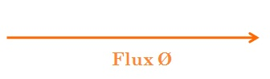

* Excitation Current Ie leading Ø by α.

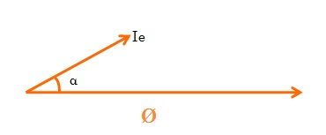

* Induced EMF E1 and E2 lagging Flux by 90 degree.

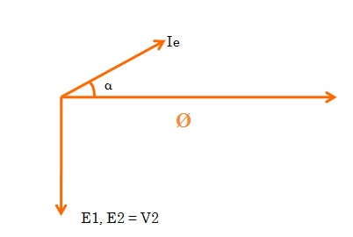

* Voltage drop r1Ie in Primary. This will be in phase with the Ie and hence shown parallel to it in the figure below.

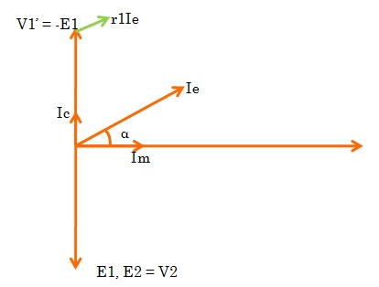

* Voltage drop IeX1 in Primary due to reactance. This will be perpendicular to Ie as shown below. (Why perpendicular to Ie? Please write in comment box.)

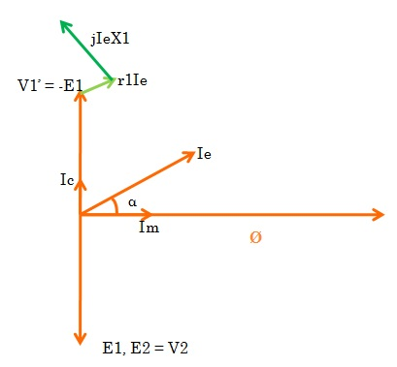

* Source Voltage V1 = V1’+r1Ie +jIeX1, phasor sum. Thus the complete phasor diagram of transformer at no load will be as shown below.

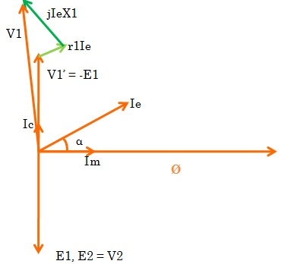

Source: <https://electricalbaba.com/phasor-diagram-transformer/>

### Draw connection groups for three-phase transformers.

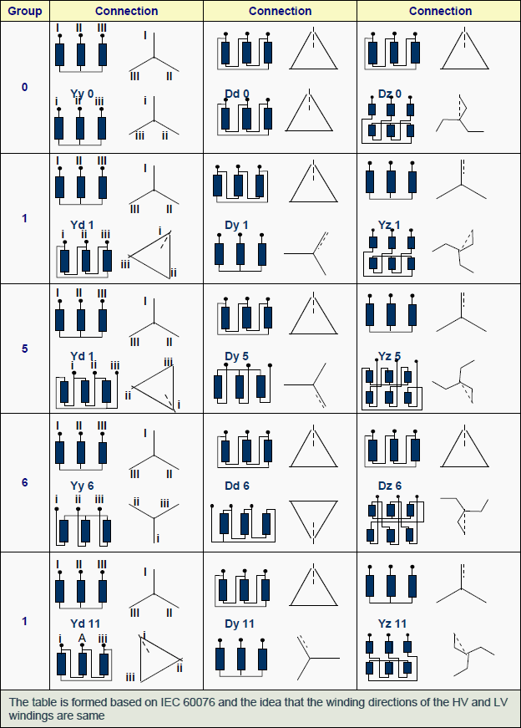

### Explain consequences for variations of voltage magnitude and frequency on operation of transformers.

1) Transformer operates with increased core losses and hence poorer efficiency.  
  
2) If you are maintaining the same voltage but higher frequency , flux ( ~ V/f ) in the transformer falls, the induced emf would hence remain the same and would not increase, unlike what has been stated in one of the answers. Although the rate of change of flux increases due to increased frequency but the value of flux is reduced and hence the overall effect is that voltage induced in the secondary remains same but at a higher frequency of course.   
  
3) If you are increasing primary voltage along with increasing frequency to maintain constant flux, only in that case the secondary voltage will increase. Therefore you can safely conclude that secondary voltage depends only upon the primary voltage and turns ratio. Look at it more simply, Vsec/Vpri = Nsec/Npri. This basic equation in a transformer doesn't relate the secondary voltage to frequency.

Source: [Quora](https://www.quora.com/What-happens-when-the-supply-frequency-of-a-transformer-increases?share=1)

### Describe phenomena which occurs during operation of two transformers in parallel.

It is economical to install numbers of smaller rated transformers in parallel than installing a bigger rated electrical power transformers. This has mainly the following advantages,

To maximize electrical power system efficiency:

Generally electrical power transformer gives the maximum efficiency at full load. If we run numbers of transformers in parallel, we can switch on only those transformers which will give the total demand by running nearer to its full load rating for that time. When load increases, we can switch none by one other transformer connected in parallel to fulfil the total demand. In this way we can run the system with maximum efficiency.

To maximize electrical power system availability:

If numbers of transformers run in parallel, we can shut down any one of them for maintenance purpose. Other parallel transformers in system will serve the load without total interruption of power.

To maximize power system reliability:

If any one of the transformers run in parallel, is tripped due to fault of other parallel transformers is the system will share the load, hence power supply may not be interrupted if the shared loads do not make other transformers over loaded.

To maximize electrical power system flexibility:

There is always a chance of increasing or decreasing future demand of power system. If it is predicted that power demand will be increased in future, there must be a provision of connecting transformers in system in parallel to fulfill the extra demand because, it is not economical from business point of view to install a bigger rated single transformer by forecasting the increased future demand as it is unnecessary investment of money. Again if future demand is decreased, transformers running in parallel can be removed from system to balance the capital investment and its return.

Conditions for Parallel Operation of Transformers

When two or more transformers run in parallel, they must satisfy the following conditions for satisfactory performance. These are the conditions for parallel operation of transformers.

* Same voltage ratio of transformer.
* Same percentage impedance.
* Same polarity.
* Same phase sequence.

Same Voltage Ratio

If two transformers of different voltage ratio are connected in parallel with same primary supply voltage, there will be a difference in secondary voltages. Now say the secondary of these transformers are connected to same bus, there will be a circulating current between secondaries and therefore between primaries also. As the internal impedance of transformer is small, a small voltage difference may cause sufficiently high circulating current causing unnecessary extra I2R loss.

Same Percentage Impedance

The current shared by two transformers running in parallel should be proportional to their MVA ratings. Again, current carried by these transformers are inversely proportional to their internal impedance. From these two statements it can be said that, impedance of transformers running in parallel are inversely proportional to their MVA ratings. In other words, percentage impedance or per unit values of impedance should be identical for all the transformers that run in parallel.

Same Polarity

Polarity of all transformers that run in parallel, should be the same otherwise huge circulating current that flows in the transformer, but no load will be fed from these transformers. Polarity of transformer means the instantaneous direction of induced emf in secondary. If the instantaneous directions of induced secondary emf in two transformers are opposite to each other when same input power is fed to both of the transformers, the transformers are said to be in opposite polarity. If the instantaneous directions of induced secondary emf in two transformers are same when same input power is fed to the both of the transformers, the transformers are said to be in same polarity.

Same Phase Sequence

The phase sequence or the order in which the phases reach their maximum positive voltage, must be identical for two parallel transformers. Otherwise, during the cycle, each pair of phases will be short circuited.

The above said conditions must be strictly followed for parallel operation of transformers but identical percentage impedance of two different transformers is difficult to achieve practically, that is why the transformers run in parallel may not have exactly same percentage impedance but the values would be as nearer as possible.

Source: <https://www.electrical4u.com/parallel-operation-of-transformers/>

# Outcome 9

## Explain operating principles of asynchronous machines.

### Describe structures and operating principles of asynchronous machines.

Asynchronous motors rotate slightly slower than the speed of the changing magnetic

flux, to provide a relative difference, which generates an electromagnet effect

on the short-circuited squirrel cage rotor. These machines can operate on single-phase. However, typically they perform significantly more efficiently and effectively on

three-phase (or greater) power.

The most common type of asynchronous electrical machine is the squirrel cage induction motor.

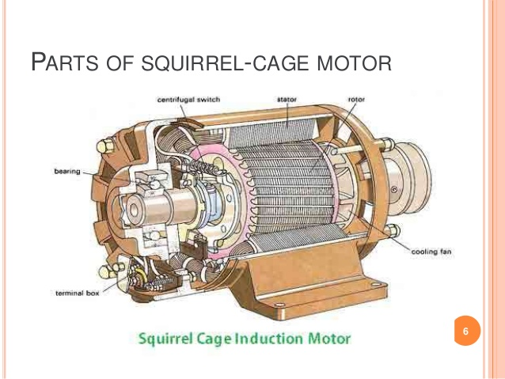

### Sketch equivalent circuits and phasor diagrams of asynchronous motors.

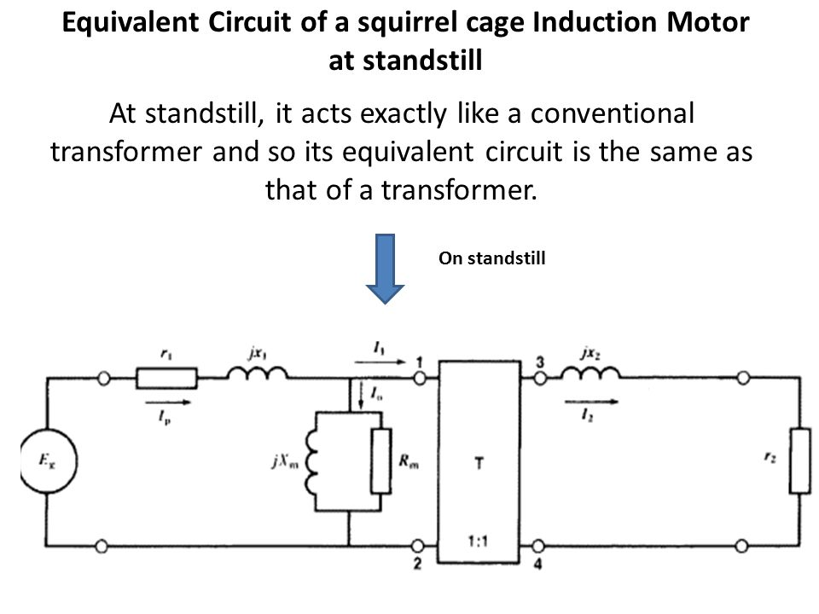

At Standstill

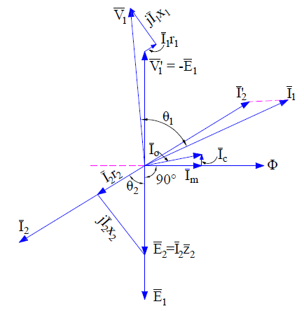

On Load

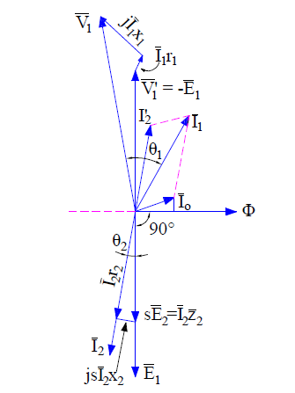

Source: <https://electricalbaba.com/induction-motor-phasor-diagram/>

### Draw an arrangement of an asynchronous motor. Identify and explain the rotor (and cage if applicable), field winding, fan, terminals and windings connections.

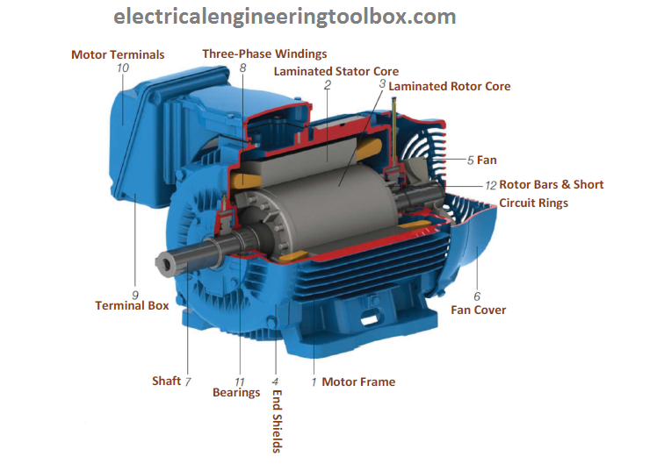

The stator is the outer most component in the motor which can be seen. It may be constructed for single phase, three phase or even poly phase motors. But only the windings on the stator vary, not the basic layout of the stator. It is almost same for any given synchronous motor or a generator. It is made up of number of stampings, which are slotted to receive the windings. The three phase windings are placed on the slots of laminated core and these windings are electrically spaced 120 degrees apart. These windings are connected as either star or delta depending upon the requirement. The leads are taken out usually three in number, brought out to the terminal box mounted on the motor frame. The insulation between the windings are generally varnish or oxide coated.

This kind of rotor consists of a cylindrical laminated core with parallel slots for carrying the rotor conductors, which are not wires, as we think, but thick, heavy bars of copper or aluminium (aluminium) or its alloys. The conductor bars are inserted from one end of the rotor and as one bar in each slot. There are end rings which are welded or electrically braced or even bolted at both ends of the rotor, thus maintaining electrical continuity. These end rings are short-circuited, after which they give a beautiful look similar to a squirrel thus the name.

One important point to be noted is that the end rings and the rotor conducting bars are permanently short-circuited, thus it is not possible to add any external resistance in series with the rotor circuit for starting purpose. The rotor conducting bars are usually not parallel to the shaft, but are purposely given slight skew. In small motors, the rotor is fabricated differently. The entire rotor core is placed in a mould and the rotor bars & end-rings are cast into one piece. The metal commonly used is aluminium alloy. Some very small rotors which operate based on eddy current, have their rotor as solid steel without any conductors.

Source: <https://www.brighthubengineering.com/diy-electronics-devices/43723-how-are-squirrel-cage-induction-motors-constructed/>

Terminal boxess typically include three phase connections marked U V W. Often these will have their counterparts U2 V2 and W2 on the other side of the motor windings in the terminal box as well, usually staggered (i.e. **U1 W2, V1 U2, W1 V2**) to allow for either a STAR or DELTA configuration depending on the users’ requirements. Often the nameplate will detail information about each configuration.

The fan is driven from the shaft of the rotor itself and is usually uni-directional, meaning flat blades in a housing which allow for air flow regardless of motor direction.

### Sketch graphs showing relations between speed and load as well as between current and load, from no load to full load.

### For a given frequency and motor structure, calculate synchronous speed and explain the term of slip.

| **Shaft rotation** [**speed**](https://www.engineeringtoolbox.com/synchronous-motor-frequency-speed-d_649.html) **- n - (rev/min, rpm)** | | | | | | |
| --- | --- | --- | --- | --- | --- | --- |
| **Frequency  - f - (Hz)** | **Number of poles - p -** | | | | | |
| **2** | **4** | **6** | **8** | **10** | **12** |
| 10 | 600 | 300 | 200 | 150 | 120 | 100 |
| 20 | 1200 | 600 | 400 | 300 | 240 | 200 |
| 30 | 1800 | 900 | 600 | 450 | 360 | 300 |
| 40 | 2400 | 1200 | 800 | 600 | 480 | 400 |
| 501) | 3000 | 1500 | 1000 | 750 | 600 | 500 |
| 602) | 3600 | 1800 | 1200 | 900 | 720 | 600 |
| 70 | 4200 | 2100 | 1400 | 1050 | 840 | 700 |
| 80 | 4800 | 2400 | 1600 | 1200 | 960 | 800 |
| 90 | 5400 | 2700 | 1800 | 1350 | 1080 | 900 |
| 100 | 6000 | 3000 | 2000 | 1500 | 1200 | 1000 |

Slip would mean the actual rotational speed would be 5-10% less than the listed RPM depending on load. For example, a 10 pole motor at 50 Hz has a synchronous speed of 600 but may be as low as 540 RPM because of slippage.

### Describe methods for AC motor start-up and speed control.

**Methods of Starting**

* Direct On Line (DOL)

Immediate connection to mains in either Delta or Star configuration. Very high inrush current. Used for most motors.

* Star Delta; Delta-Wye (Y-D)

Temporary star configuration for reduced inrush current before switching to delta, approximately a third of DOL current. Used for large pumps which start under load.

* Autotransformer (buck)

Buck transformer is a transformer connected electrically and magnetically which reduces the voltage to the motor. A switch may be used similar to star-delta when at speed.

* Variable Frequency Drive (VFD) / Frequency Converter (FC)

Either AC to AC (cycloconverter) or AC-AC with a DC bridge (synchroconverter) which produces a pulse width modulated or complex waveform using switching transistors or thyristors. Allows for variable speed and massively reduced starting current.

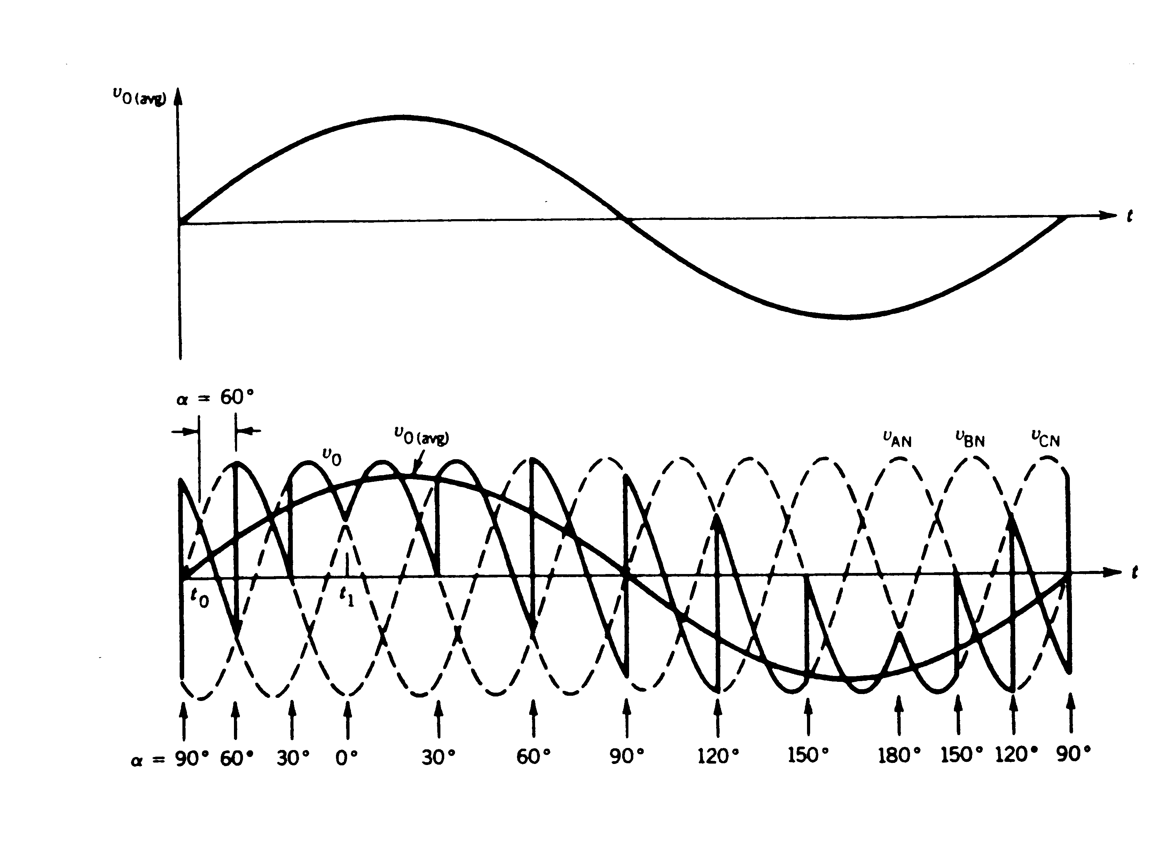

Cycloconverter Waveform (AC/AC, up to 33% of original f)

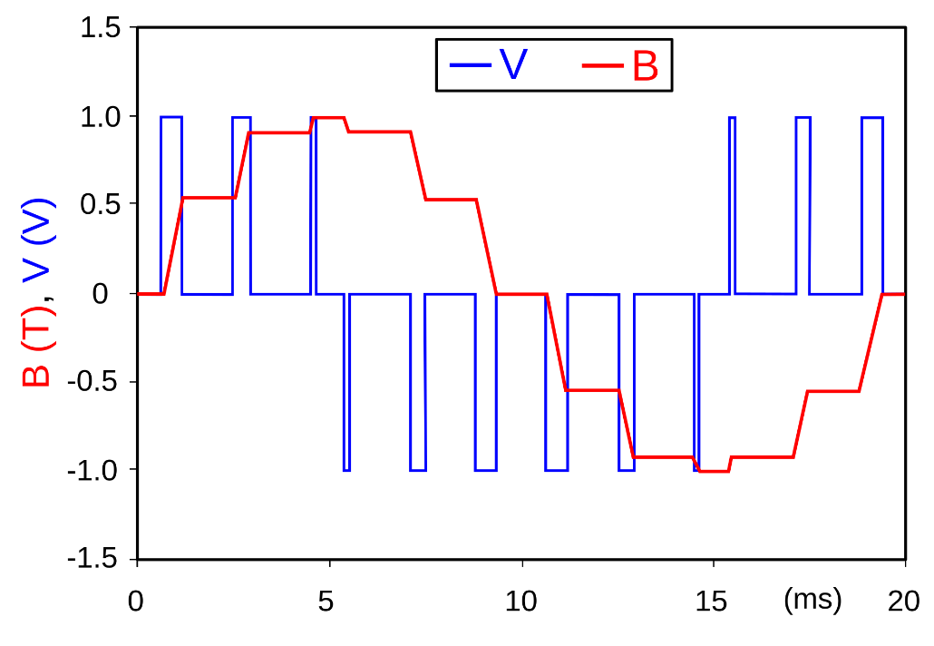

Synchroconverter Waveform (up to 400%+ of original f)

* Eddy Current Clutch

The clutch contains a fixed speed rotor and an adjustable speed rotor separated by a small air gap. A direct current in a field coil produces a magnetic field that determines the torque transmitted from the input rotor to the output rotor. Rare.

* Wound Rotor Induction Motor Drive (WRIM)

WRIM drive controls speed by varying motor slip via rotor slip rings either by electronically recovering slip power fed back to the stator bus or by varying the resistance of external resistors in the rotor circuit.

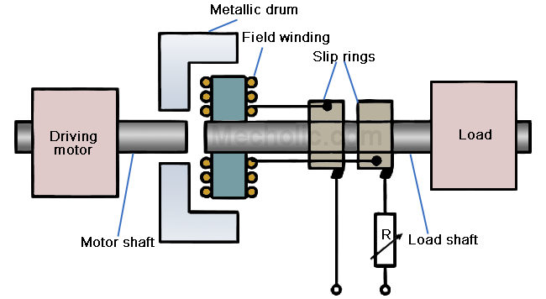

* A Gearbox

### Describe double squirrel-cage and deep slot motors.

The ordinary squirrel cage induction motor has excellent running characteristics, but it suffers from the drawback that due to its very low rotor resistance, it’s starting torque is poor.  
   
The starting torque can be improved by increasing the rotor resistance but in case of squirrel cage induction motor external resistance can’t be added in the rotor circuit during starting since its rotor is permanently short circuited.  
   
If the rotor circuit is made of high resistance to obtain high starting torque, then the motor will have poor efficiency under normal running condition because of more rotor copper losses.  
   
However, the starting torque of this motor can be improved by employing another cage on the rotor, and the motor is called **double squirrel cage induction motor.**

**Construction of Double Squirrel Cage Induction Motor**

[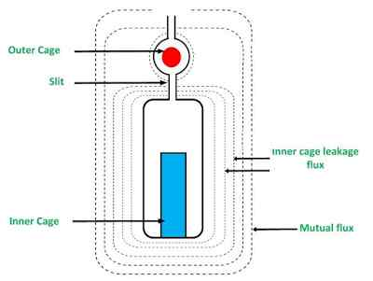](https://www.yourelectricalguide.com/wp-content/uploads/2018/10/double-squirrel-cage-induction-motor.jpg)

   
A double squirrel cage induction motor consists of a rotor which has two independent cages one above the other in the same slot. A double squirrel cage rotor is shown in the figure.

The upper slot conductors from the outer cage and the lower slot conductors forms the inner cage. The outer cage consists of bars of high resistance, generally bars of brass alloy of a smaller area of cross-section, are employed.  
   
The inner cage consists of bars of low resistance generally bars of copper metal of a larger area of cross section, are employed. Since the inner cage is embedded deep in the iron, it has relatively more leakage flux and has high reactance.  
   
Thus the outer cage has high resistance and low reactance whereas the inner cage has low resistance and high reactance.  
   
A slit is provided between upper and lower slot so that it offers high reluctance for the stator field. Thus, the stator field instead of linking with only outer cage, links both the cages simultaneously.

Source: <https://www.yourelectricalguide.com/2017/07/double-squirrel-cage-induction-motor.html>

The **Deep Bar Rotor** in an induction motor is used to obtain high rotor resistance at starting and low rotor resistance at the running condition. The figure below shows a deep bar cage rotor with deep and narrow bars.

[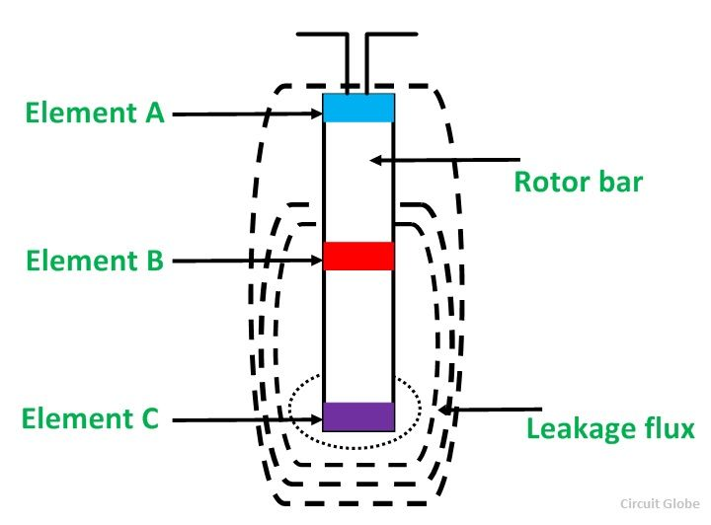](https://circuitglobe.com/wp-content/uploads/2016/01/Deep-bar-rotor-fig-1.jpg)

A bar may be assumed to be made up of several narrow layers connected in parallel. The above figure shows **three layers A, B** and **C**. The topmost layer element that is denoted by A is linked with the **minimum leakage flux**. Its leakage inductance is minimum. On the other hand, the bottom layer C links with the **maximum leakage flux** and thus, its leakage inductance is maximum.

At the starting, the frequency of the rotor is equal to the supply frequency. The bottom layer element C offers more impedance to the flow of current than the top layer element A. Therefore; maximum current flows through the top layer and minimum current flows through the bottom layer.

The effective rotor resistance increases and the leakage reactance decreases, and this is because of the unequal current distribution of the current. The starting torque and the starting current is higher and lower, respectively because of the high rotor resistance at the starting condition.

The value of a slip and the frequency of the rotor is very small, under the normal operating conditions. The reactances of all the layers of the bars is small as compared to their resistances. The impedance of all layers of the bar is nearly equal, so the current flows through all parts of the bar equally. The rotor resistance of the motor is small because of the large cross-sectional area makes the rotor resistance small, which results in a better efficiency at the lower slip.

Source: <https://circuitglobe.com/deep-bar-rotor.html>

### Explain the meaning of the information displayed on a motor name plate.

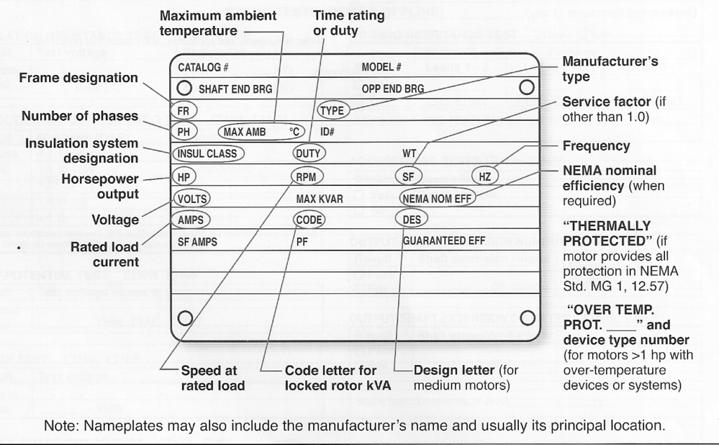

### Explain consequences of supply voltage and frequency variation on operation of asynchronous motors.

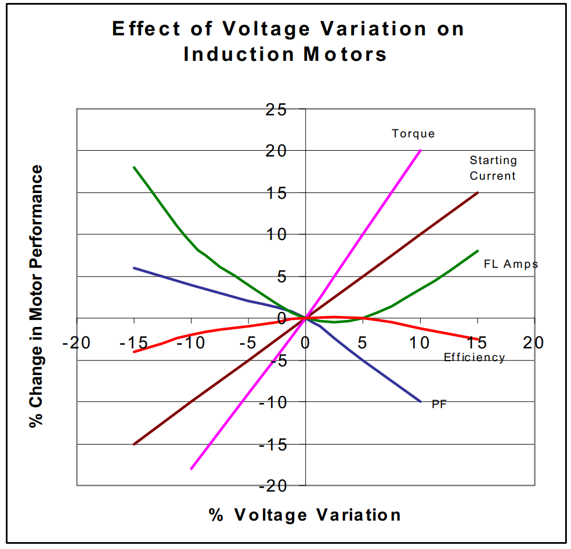

When both voltage and frequency are changed at the same time, a motor can operate  
successfully if the voltage ¸ frequency (volts/Hz) ratio is kept constant. For example, if a  
460V, 60Hz motor is operated at 380V, 50Hz the motor will be able to provide full rated  
torque. (There will be a slight increase in temperature due to reduced fan speed.) The  
motor will rotate at 5/6th of the speed. Since HP = (T x RPM) ¸ 5250 the output HP will  
be 5/6th as much as the 60Hz nameplate indicates. This means that to produce full HP,  
the torque output must increase by 6/5th. Some motors, because they run cooler than  
the rating of the insulation, may be able to successfully produce the full HP rating of the  
motor (but at a higher temperature rise). The Toolbox contains an Excel spread sheet  
titled “50Hz Temp Rise 1-12-98” that calculates the expected 50Hz temperature rise at  
full HP loading.

The percent voltage unbalance is defined as: 100 times the sum of the deviation of the  
three phases from average without regard to sign, divided by twice the average voltage.  
For example, a 220V system with phase voltages of 215, 221 & 224 would have a  
voltage unbalance of:  
(220 - 215) + (221 - 220) + (224 - 220) x 100 = 2.27%  
2 x 220  
When voltage unbalance increases, locked rotor torque reduces slightly. Speed does  
not change appreciably but does decrease slightly. Temperature rise, however,  
increases dramatically. Although there are no hard and fast rules, the tendency is that  
the percentage increase in temperature rise is usually twice the square of the  
percentage of voltage unbalance. For example, if a motor is subjected to a 4% voltage  
imbalance, the resulting temperature increase will be approximately 2 x (4%)2 = 32%

Source: <https://www.landbelectric.com/download-document/88-effects-of-voltage-frequency-variations-on-induction-motors.html>

# Outcome 10

## Explain operating principles of synchronous machines.

### Describe structures and operating principles of synchronous machines.

A synchronous electric motor is an AC motor in which, at steady state, the rotation of the shaft is synchronized with the frequency of the supply current; the rotation period is exactly equal to an integral number of AC cycles.

Source: <https://en.wikipedia.org/wiki/Synchronous_motor>

### Describe properties of synchronous generators.

Brushes ride directly on the slip rings and make electrical contact with the external terminals. Brushes wear down eventually, so they must be inspected periodically and replaced as needed.

Large synchronous generators require an excitation voltage for the field. This voltage comes from a separate power source such as a smaller auxiliary dc generator called an exciter to supply field current.

Usually, the exciter is mounted on the main shaft. Different types of exciters include separate exciters that are dc generators, static exciters (with no rotating parts), and shaft-driven dc exciters. Current from the exciter is usually controlled by an automatic or manual regulator.

In **one type**, the armature is the rotor, and current from the armature is generated in the rotor; this is called a **rotating armature ac generator**. In this case, slip rings and brushes are used to pass current from the rotor through insulated porcelain bushings to the electrical terminals on the frame of the generator.

The **other type** has the field on the rotor and the armature on the stator. In this case, slip rings and brushes may not be necessary because power is produced in the stationary stator, and rotor current can be supplied from a separate rotating exciter that is mounted on the same shaft. This is called a **rotating-field ac generator**.

Source: <https://electricalacademia.com/synchronous-machines/ac-synchronous-generator-working-principle-types/>

### Explain armature reaction.

When the load on the DC motor increases the armature current increases. The armature current set up the magnetic flux which opposes the main field flux.

**Thus the net field flux gets reduced. This phenomenon is called the armature reaction.**

The motor performance gets adversely affected due to reduction of the field flux.

1. The motor attains the speed above its designed rated speed.
2. The torque delivering capacity of the motor gets reduced.

To nullify the effect of armature reaction, the additional field winding is connected in the series with the armature winding to produce the additional amount of the flux to compensate for the armature reaction.

Source: <https://www.quora.com/What-is-armature-reaction-in-dc-motor?share=1>

### Sketch equivalent circuits and phasor diagrams for synchronous generators.

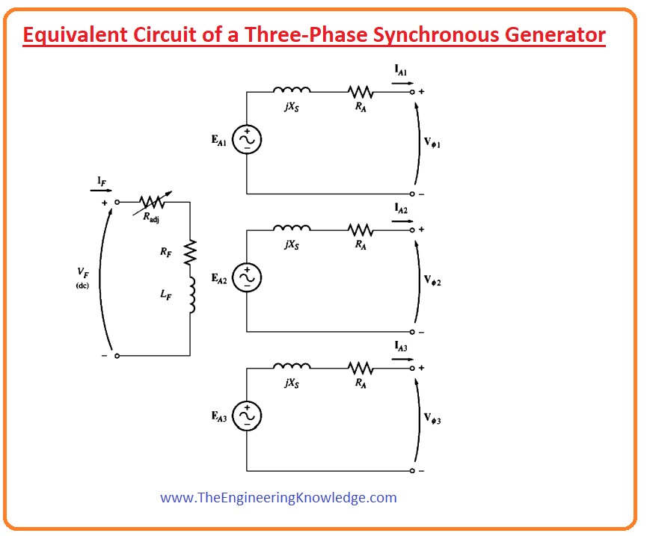

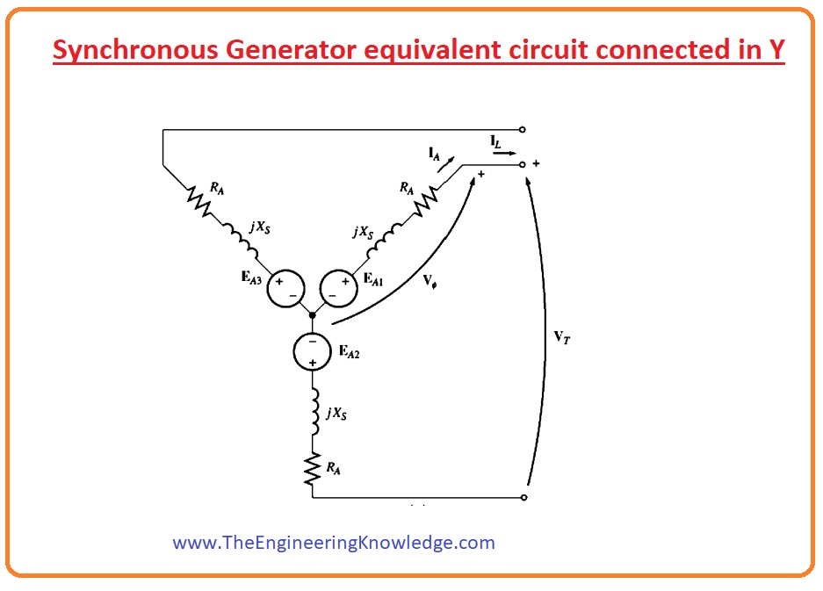

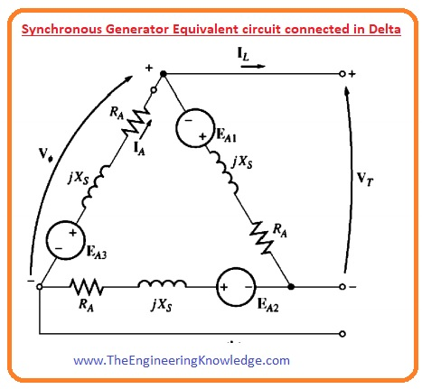

Source: <https://www.theengineeringknowledge.com/what-is-the-equivalent-circuit-of-synchronous-generator/>

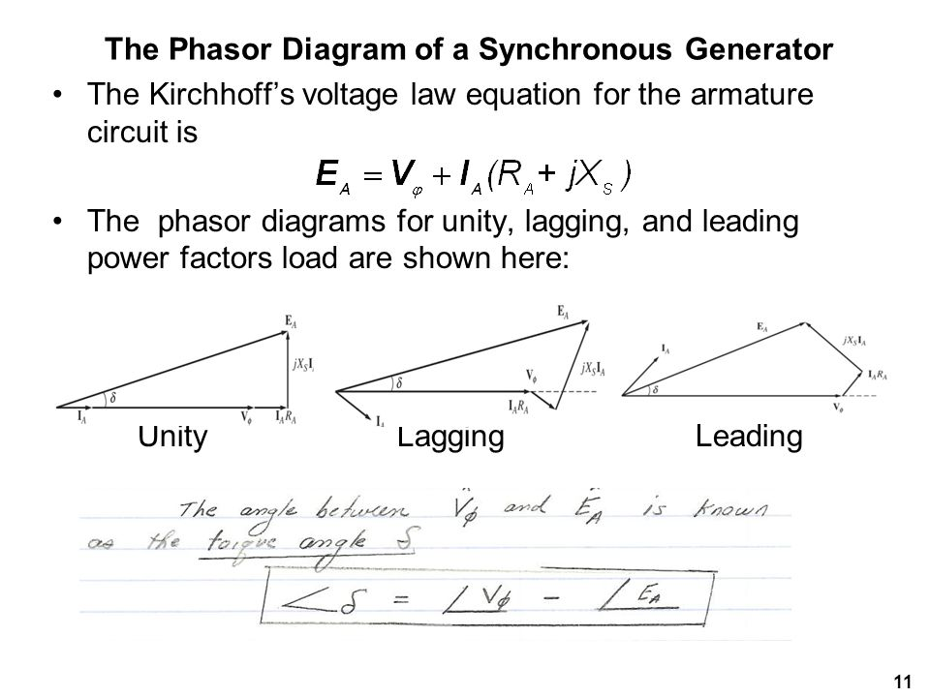

### Explain the operation of the synchronous machine as motor and pf compensator.

An over-excited synchronous motor has a leading power factor. This type of machine has a free-spinning shaft and is often referred to as a synchronous condenser. Its purpose is to generate leading [absorb lagging] power factor. These may be DVR (PLC) controlled for maintain a specific power factor in industrial loads.

Synchronous motors are categorized as either non-excited (i.e. Reluctance, Hysteresis, Permanent Magnet) or DC-excited.

In DC-excited motors, current must be induced onto the rotor windings. The simplest method for accomplishing this is slip rings and brushes. This typically works fine for machines which have lower RPMs, as the greater the rotational speed, the greater the friction and therefore the greater the maintenance required. That being said, it is not uncommon to find these in handheld power tools which operate at incredible rotational velocities.

The other method for applying power to a synchronous machine’s rotor is essentially a transformer – an inductor with AC passing through it as the primary and a winding on the rotor itself as a secondary – with a bridge rectifier placed on the rotor itself to rectify the resultant AC to DC for use in excitation.

Non-excited motors will be discussed in Outcome 11.

### Compare properties of cylindrical and salient pole machines.

|  |  |
| --- | --- |
| **Cylindrical** | **Salient Pole** |
| The unslotted portion of the cylinder acts as the poles, therefore no “saliency” | Poles are projecting out from the surface. “Salient” |
| The air gap is uniform due to the smooth cylindrical periphery. | The air gap is non-uniform. |
| Small diameter and the large axial length. | Large diameter and small axial length |
| Mechanically strong. | Mechanically weak |
| Preferred for high-speed alternators | Better for low-speed alternators |
| For the same size, the rating is higher than Salient pole type. | Rating is generally smaller than cylindrical machines at the same size |
| Best for high-speed alternators ranging from 1000 RPM to 3000 RPM. | Best for low-speed alternators between 125 and 500 RPM |

# Outcome 11

## Explain the operating principles of special machines.

### Describe the construction and operating principles of AC commutator motors, AC single-phase motors, and reluctance and permanent magnet machines.

AC Commutator motors, or “universal” motors have a stator and armature in series via brushes. This allows the motor to rotate in the same direction regardless of supply polarization. They may also be single or poly phase motors whose starting torque and rotation velocity are greater than that of regular induction motors.

Single phase AC motors are either a permanent split capacitor motor, which has two field windings electrically 90 degrees apart and a capacitor in series with one of the windings. By moving this capacitor to be in series with the other winding the motor can be reversed. These motors have less losses than a shaded pole motor, however have a limited duty cycle and work best under 400W.

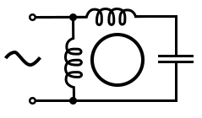

Alternatively, they may be a cap-start or cap-start-cap-run motor. This motor uses a centrifugal switch to switch out a capacitor once a certain RPM is reached to maintain a rotating flux on a single phase. A cap-start-cap-run motor is the same except instead of a single capacitor switching out, a small capacitor is switched, generally of a different make (polymer type) rather than electrolytic due to losses.

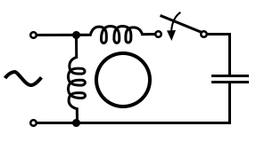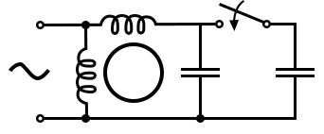

A resistance split phase motor operates on much the same principle as a cap-start motor but switches a lower impedance winding allowing a phase difference of 15-45 degrees.

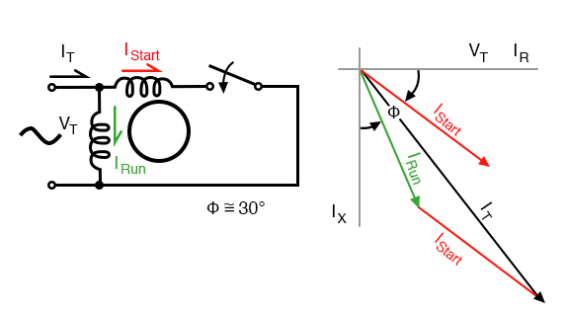

# Outcome 12

## Demonstrate operating principles of electronics and power electronics.

### Describe the structure, principle of operation, parameters and application of different semiconductor elements: diodes, SCR, GTO and IGCT thyristors, field effect transistors — MOSFET and JFET, IGBT transistors.

* Diodes

### 

* Silicone Controlled Rectifier (PNPN)

There are three modes of operation for an SCR depending upon the biasing given to it:

1. Forward blocking mode (off state)
2. Forward conduction mode (on state)
3. Reverse blocking mode (off state)

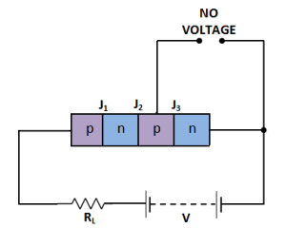

* Gate turn off thyristor (GTO)

Like a thyristor but may be turned on and off by their gate. Regular thyristors can be turned on by their gate but not off.

* Integrated gate-commutated thyristor

Similar to a GTO, an IGCT can be turned on or off by their gate, but also allow for higher rates of voltage rise. Essentially the power electronics version of a GTO.

* FETs or Field Effect Transistors

Uses an electric field to control current flow with a high input impedance. 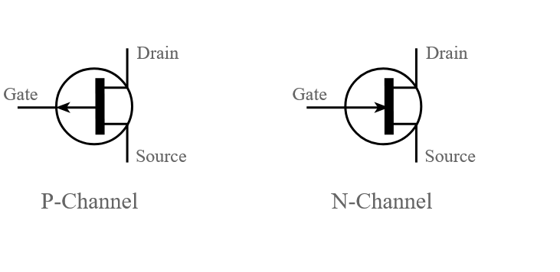

MOSFET

A metal–oxide–semiconductor field-effect transistor (MOSFET, MOS-FET, or MOS FET) is a field-effect transistor where the voltage determines the conductivity of the device. It is used for switching or amplifying signals and is extremely common.

JFET

A JFET is a field effect transistor which allows for variable current flow by applying a variable voltage. Unlike a MOSFET, they are only depletion, not enhancement. They also have a lower impedance than MOSFETs but are cheaper to produce. Simply, they accomplish very similar tasks but are just not as common.

IGBT

Insulated gate bipolar transistors are field effect transistors are transistors used for switching significantly larger currents than their FET cousins.

### List classification of power electronic converters and areas of their application on ships.

DC to DC Converters

Buck or boost DC/DC converters are not able to be used in power electronics

AC to AC Converters

Transformers are extremely common aboard vessel for stepping down a higher generated voltage to a manageable domestic voltage. Every ship uses transformers. HV vessels will also use them, sometimes oil immersed, for propulsion.

Cycloconverters may also be used for propulsion as the very low frequency resultant will often be more than enough to meet the 0-140 RPM of most vessel propellers.

AC to DC rectifiers

Uncontrolled

Diode-only rectifiers are common aboard vessels but not for power electronics. Synchronous AC motors will use them, with the AC induced on the rotor and rectified, if the vessel is equipped with such motors.

Controlled

Using thyristors or SCRs instead of diodes allows for more precise voltage and sinewave management. These are common aboard vessels for battery charging.

DC to AC inverters

Synchroconverters may be used for HV propulsion and is the most common form of variable speed drive in any application on board the vessel where frequency under 200Hz are acceptable.

### List parameters, properties and basic applications of integrated stabilizers and operational amplifiers.

An Operational Amplifier or op-amp is a voltage amplifying device designed to be used with external feedback components such as resistors and capacitors between its output and input terminals. It is a high-gain electronic voltage amplifier with a differential input and usually a single-ended output. An Op-amp can perform many arithmetic operations like- addition, subtraction, multiplication, division, integration, differentiation etc and it can also amplify the voltage signal present at the input, allowing for nearly lossless gain in signals (i.e. audio).

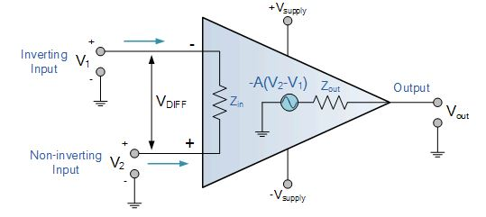

Source: <https://www.electronicsforu.com/resources/learn-electronics/operational-amplifier-basics>

A Marine Gyrostabilizer comprises of a spinning flywheel mounted in a gimbal frame allowing two of the three possible rotational degrees of freedom. Without any intervention, the vessel’s rolling motion combines with the flywheel angular momentum to cause an oscillating process motion. This then combines with the angular momentum to create stabilizing torque, which directly opposes the wave induced rolling motion of the vessel. All this happens in the same instant and is perfectly synchronised. Essentially, the larger the stabilizer, the greater the accuracy for traditional gyrostabilizers.

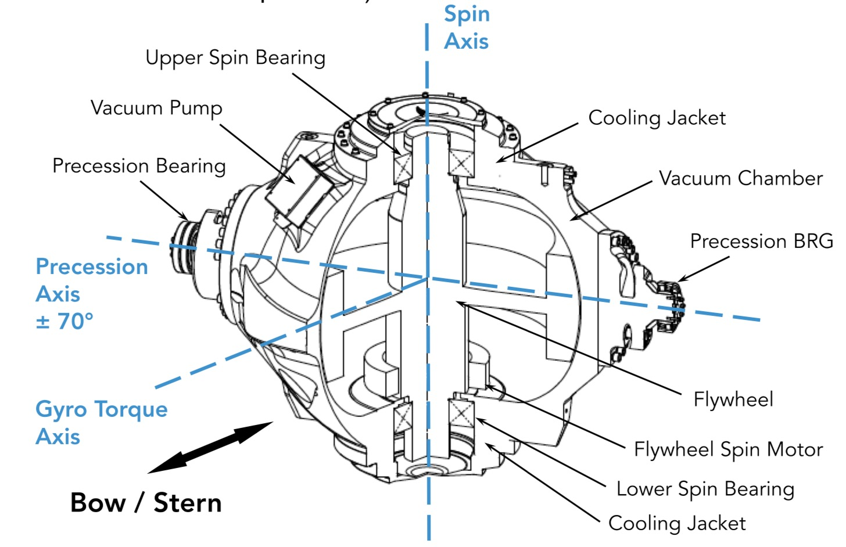

### Describe structure and operation of analogue and impulse DC power supplies.

Linear / analog DC power supplies transform an AC sinewave to a lower voltage and then rectify the sinewave using diodes (usually full bridge rectifier) and then smooth the resultant DC with a capacitor.

For switch mode / impulse DC power supplies, the input DC supply from a rectifier or battery is fed to the inverter where it is turned on and off at high frequencies of between 20 KHz and 200 KHz by the switching MOSFETs or power transistors. The high-frequency voltage pulses from the inverter are fed to the transformer primary winding, and the secondary AC output is rectified and smoothed to produce the required DC voltages. Generally a feedback circuit monitors and adjusts the output voltage as necessary. These are extremely efficient but produce potentially harmful harmonics.

### Describe the construction and operation of controlled rectifiers.

Controlled rectifiers use SCRs or thyristors with feedback to a chip of some kind to adjust the switching action as needed.

### Describe the construction and operation of AC voltage controllers.

The most common form of AC voltage control are the triac and inverse parallel SCR couple. These switch the fixed frequency fixed voltage AC supply to adjust the voltage.

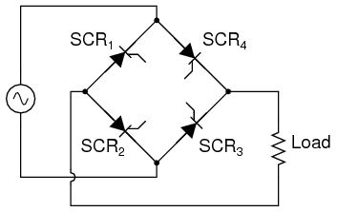

### Describe the principle of operation and properties of cyclo-converters.

Cycloconverters use extremely fast switching of an AC sinewave to produce a secondary AC complex wave (generally made of sawtooth-type shapes) which is up to a maximum of 50% of the original frequency (e.g. 50 to 25Hz)

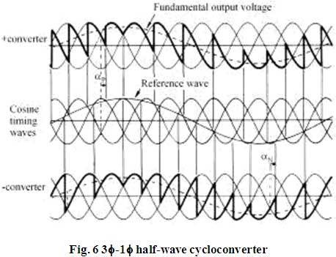

Cycloconverters are a method of achieving a variable frequency with no intermediate DC link

### List diagnostics, methods of assembly and replacement of semiconductor elements.

A semiconductor material has an electrical conductivity value falling between that of a conductor, such as metallic copper, and an insulator, such as glass. Its resistance falls as its temperature rises; metals are the opposite. Its conducting properties may be altered in useful ways by introducing impurities into the crystal structure.

Source: <https://en.wikipedia.org/wiki/Semiconductor>

The most common semiconductor material is silicone, whose isotypes hold opposite (P and N) conductive properties depending on the amount of impurities (e.g. arsenic) introduced. In addition it is extremely cheap to manufacture and of extremely small physical size.

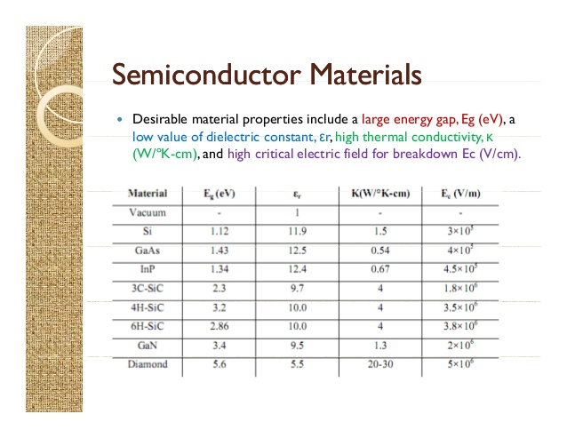

### List the requirements for electronic and power electronic systems installed on ships.

* Vibration resistance
* Ingress Protection (IP rating)
* Thermal resistance
* Redundant and fail-to-safe
* Durable construction